**Load Balancer Tasks:**

**1.Configure Classic Load balancer:**

Navigate to VPC and create a VPC

Created with a CIDR range- 198.162.0.0/20

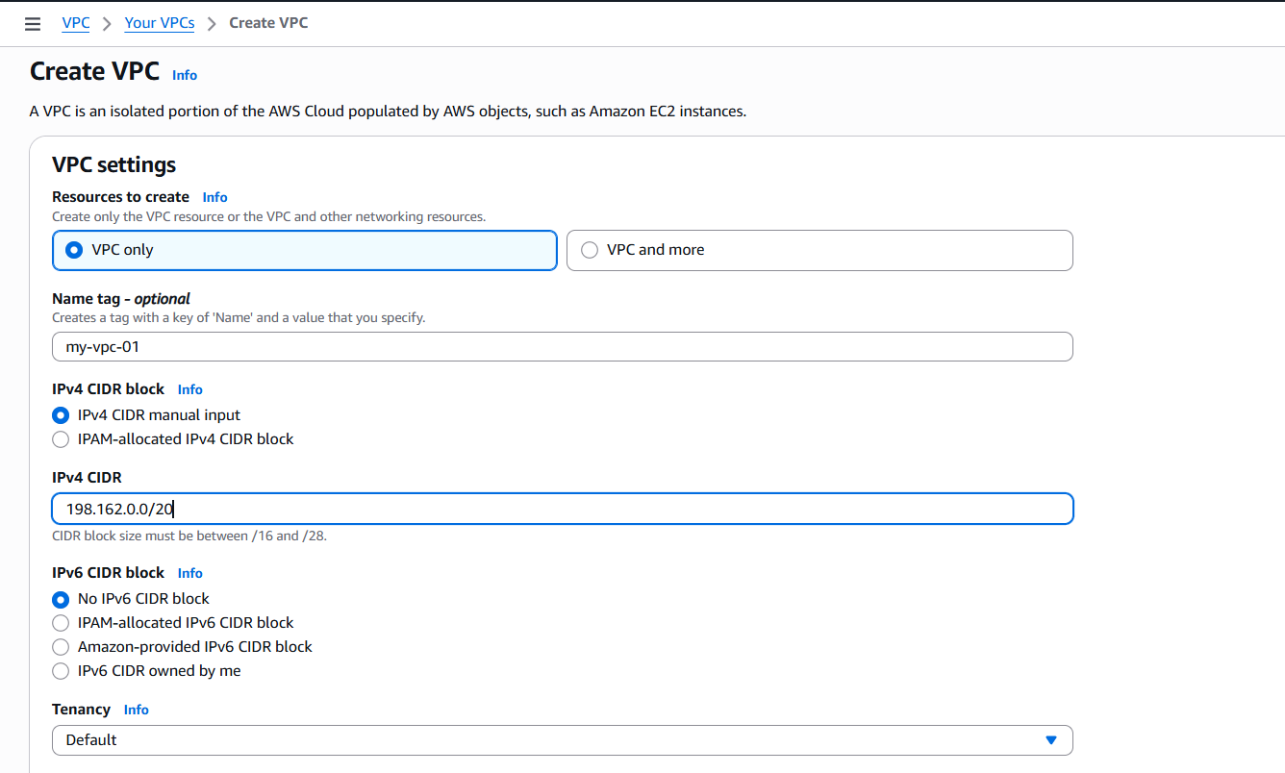

VPC created successfully.

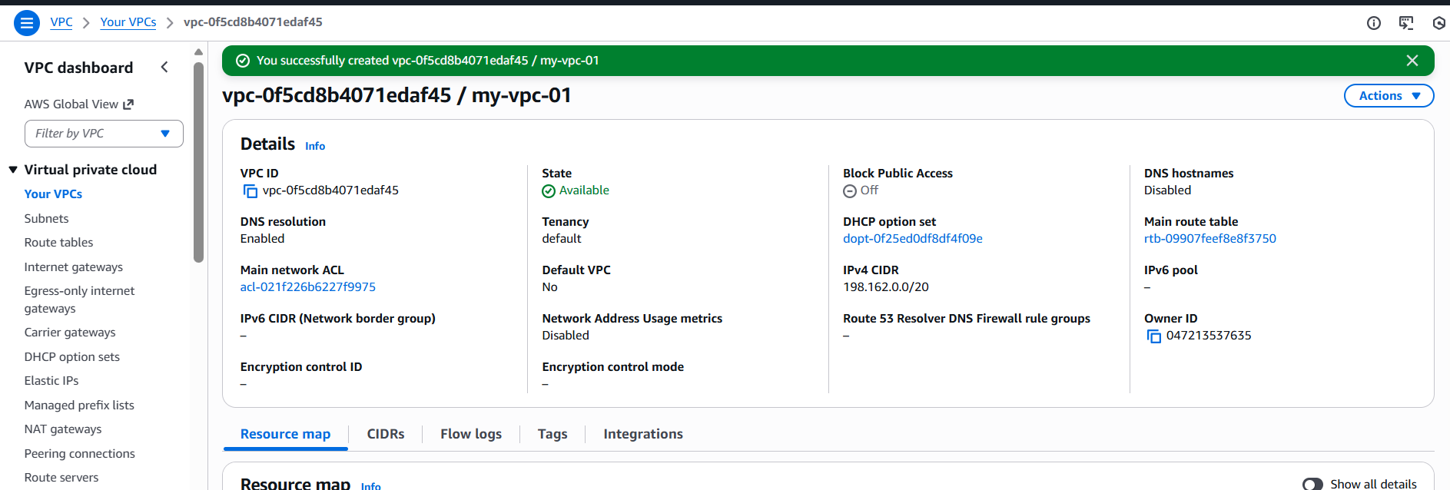

**Step 2:** Now, lets create 2 subnets in 2 different availability zones.

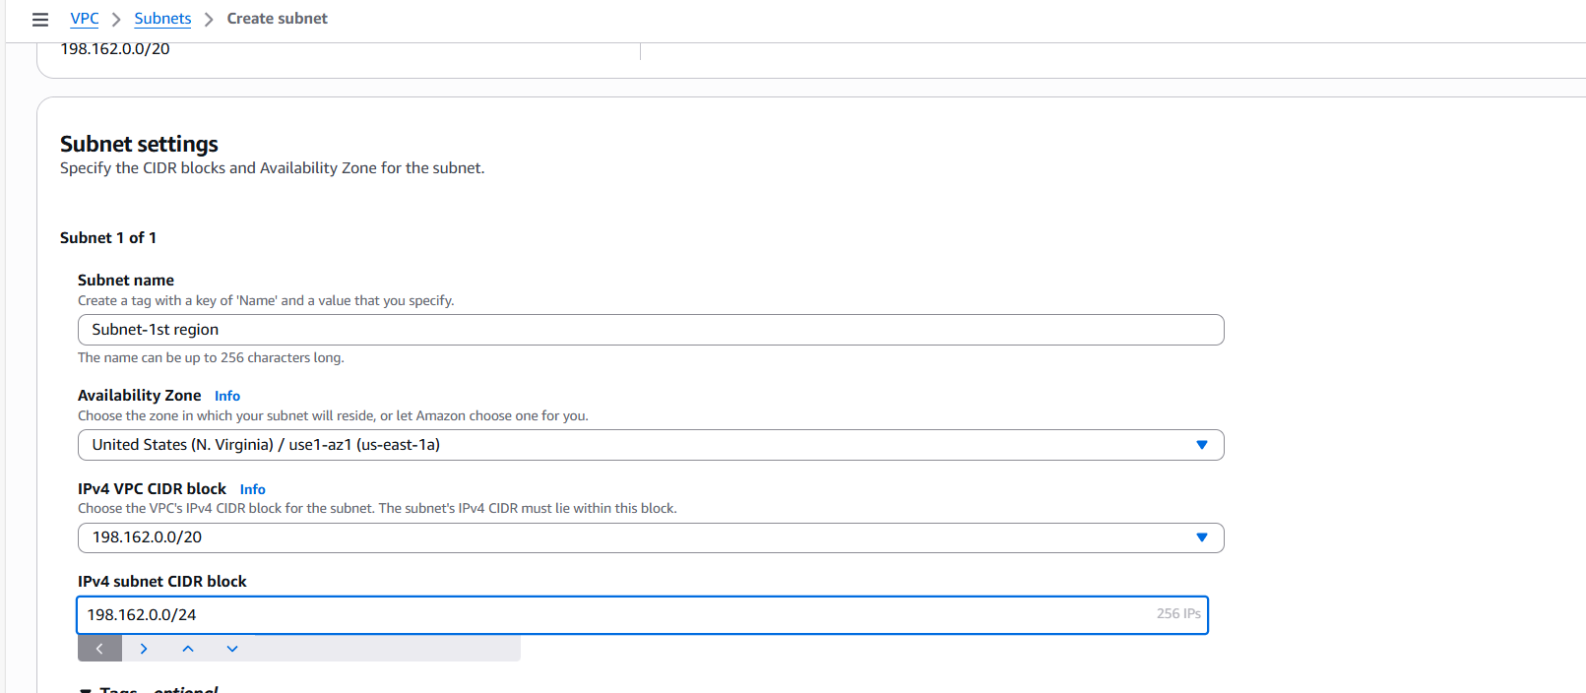

Subnet created in us-east-1 availability zone.

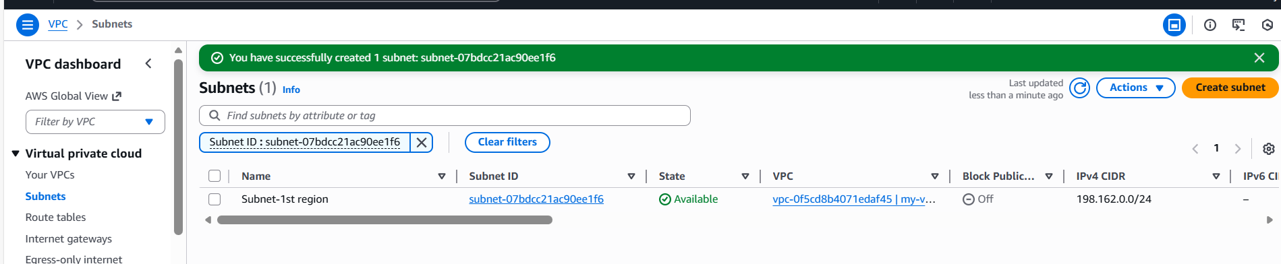

Let’s create 2nd subnet in 2nd availability zone.

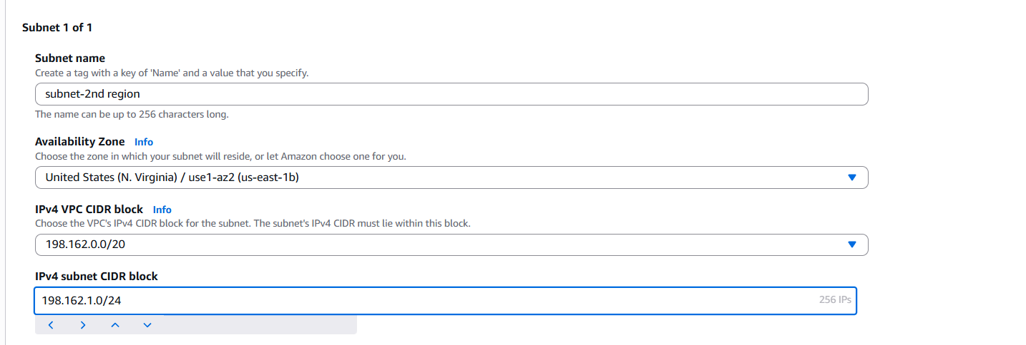

2nd Subnet created successfully in us-east-2.

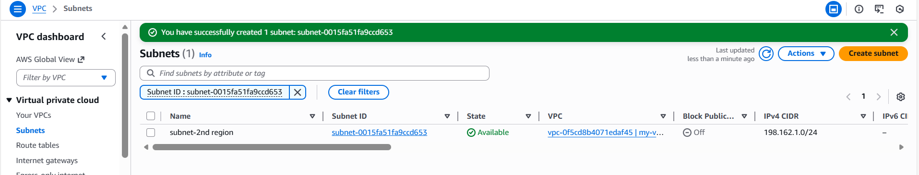

Now, lets create a Internet Gateway

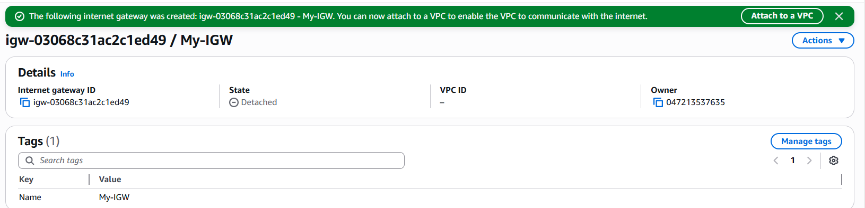

Let’s attach VPC to the IGW

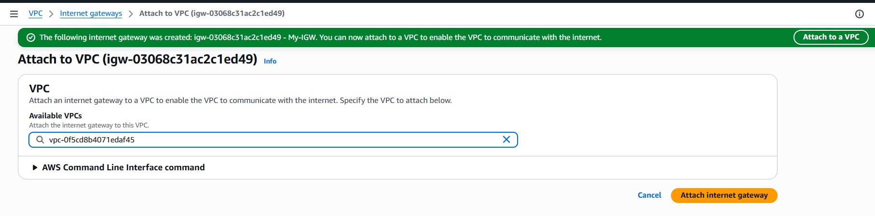

Let’s create a route table and attach the IGW.

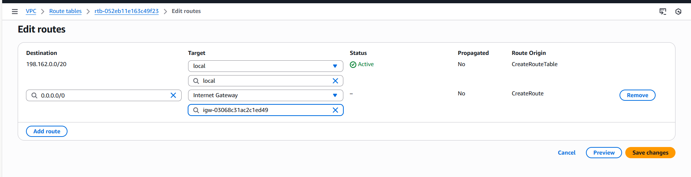

Now attach the subnets to get internet access.

Attached subnets to the route table to get internet access.

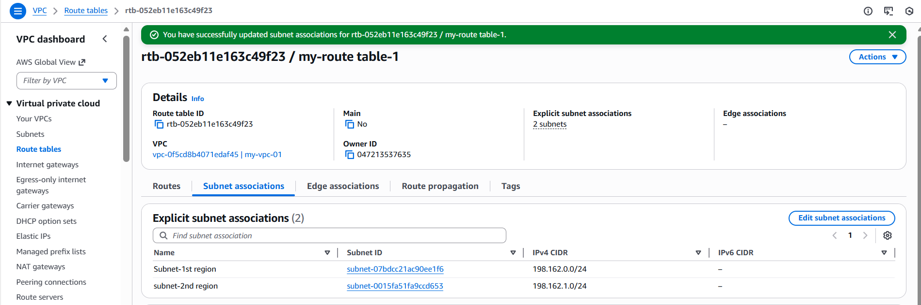

Let’s create 2 ec2’s and attach subnets created.

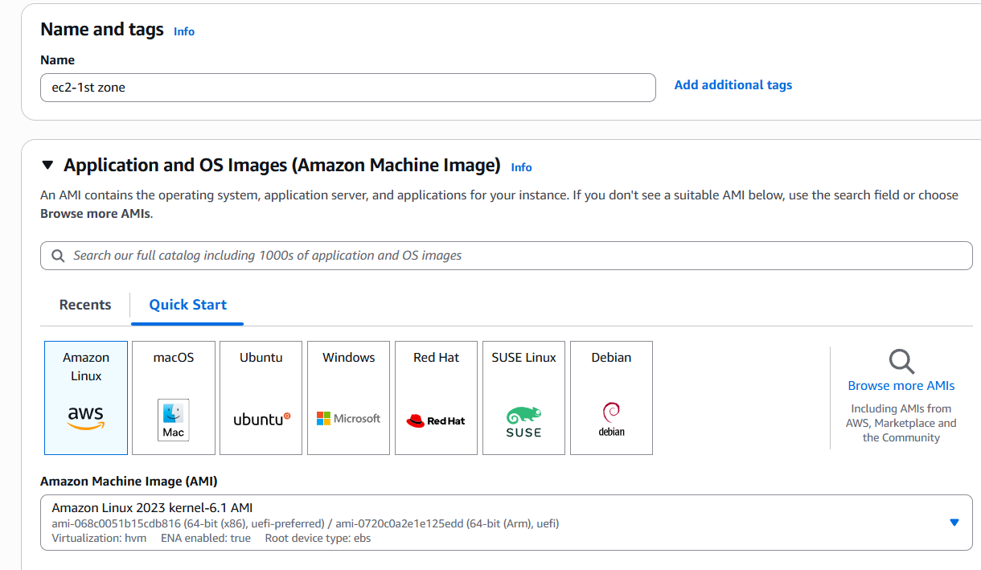

Attached VPC and subnet created for 1st availability zone.

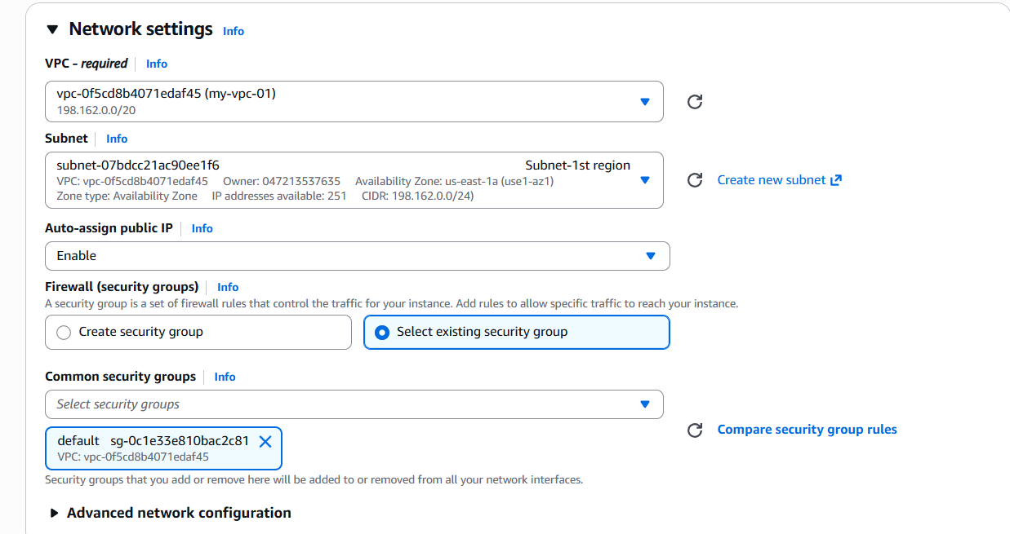

To install httpd on launching the instance, updated the script to enable Apache.

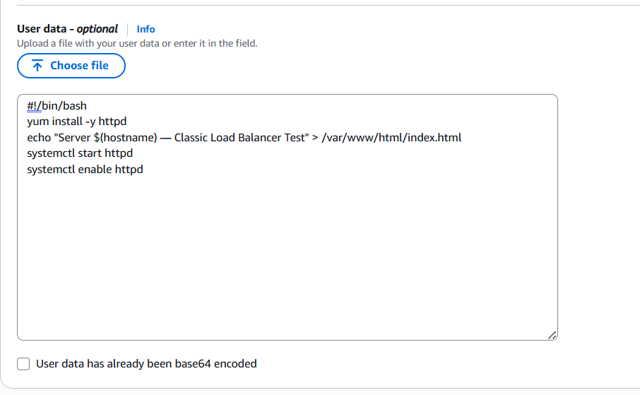

Successfully launched the 1st instance.

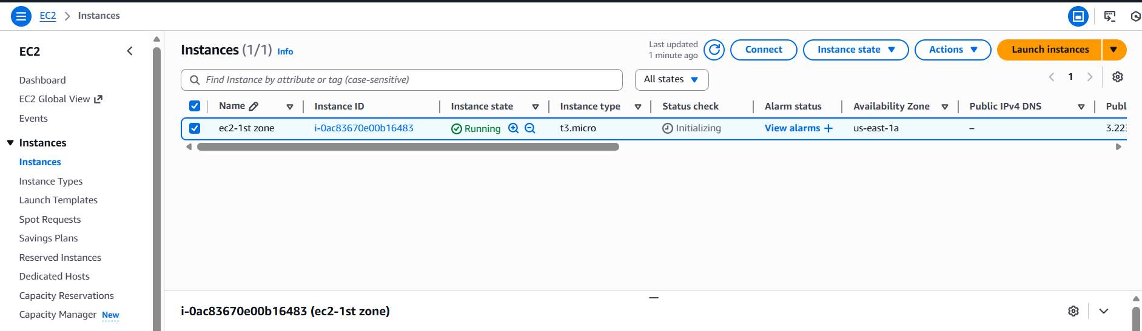

Now, lets launch the second instance with 2nd subnet in second availability zone.

Second Instance launched successfully with User Data updated to launch Apache application on default.

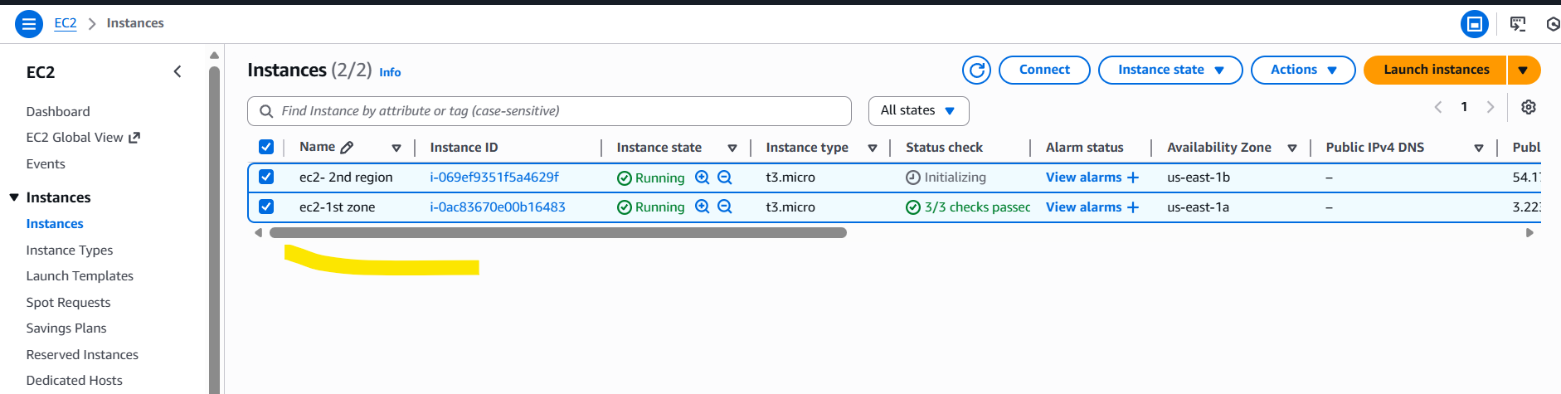

Let’s update Security groups to those instances.

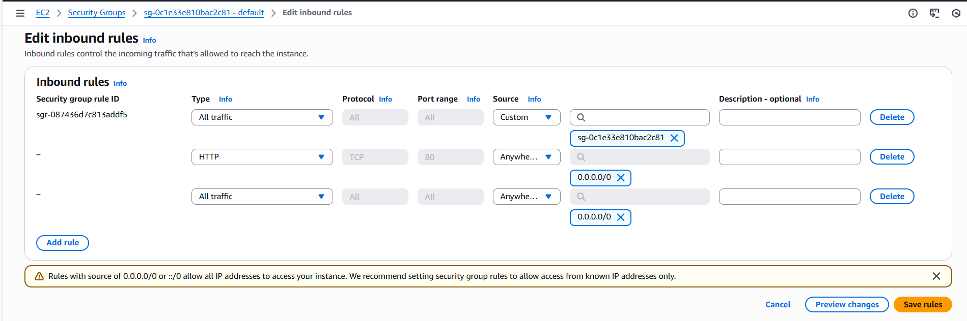

Updated Security groups to second instance as well to allow- http and all traffic.

Launched 1st instance to verify if Apache is installed and running.

Success, its running as expected.

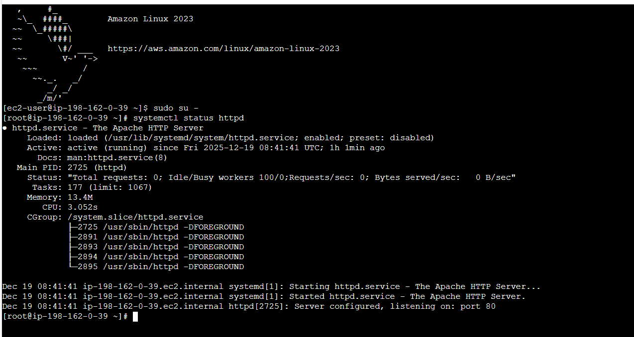

Verified on browser and its working as expected.

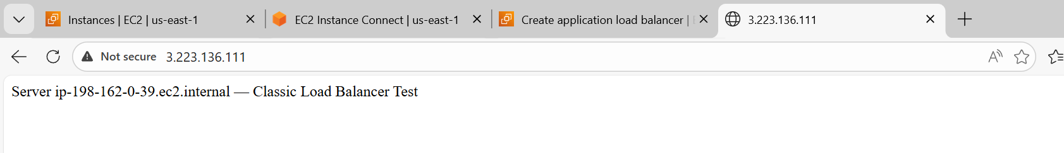

**Step 9:** Let’s verify the second instance by connecting to server.

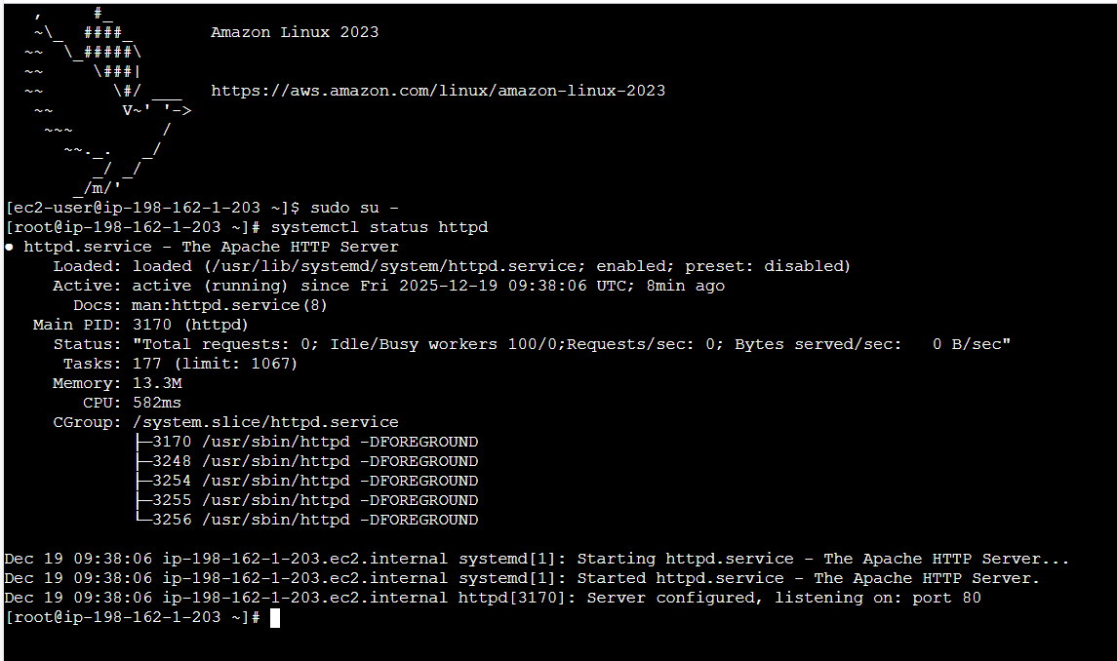

Verified on browser and its working as expected.

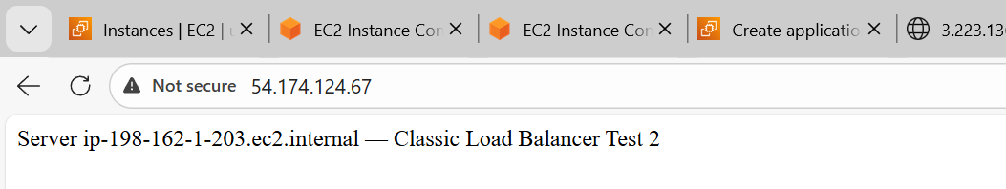

Its time to launch the Load balancer as we are all set with VPC 🡪 Instances 🡪 httpd server created.

Navigate to ec2 🡪 Create load balancer

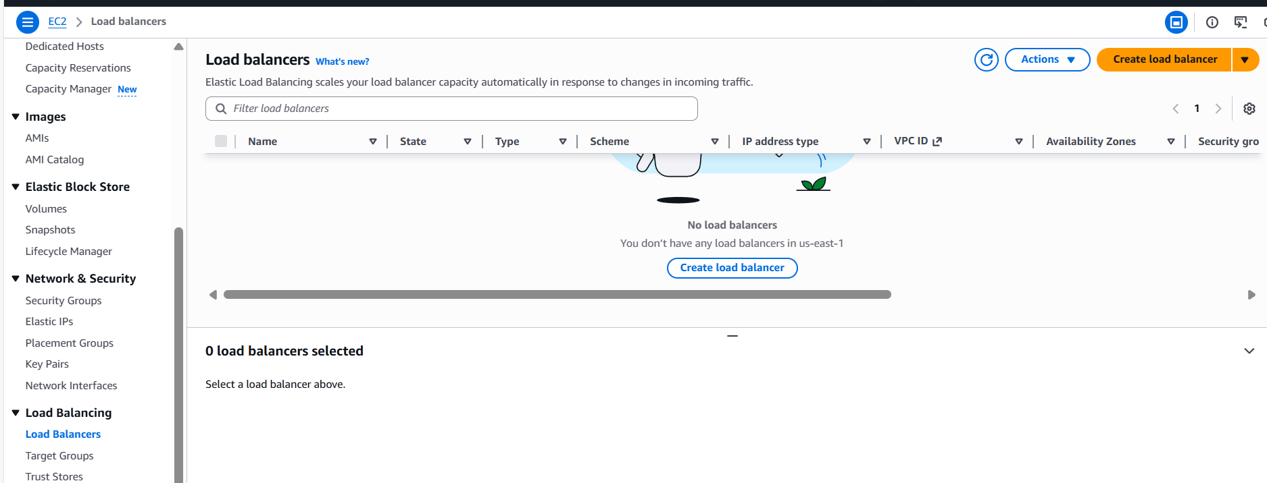

Creating Classic Load Balancer for my requirement.

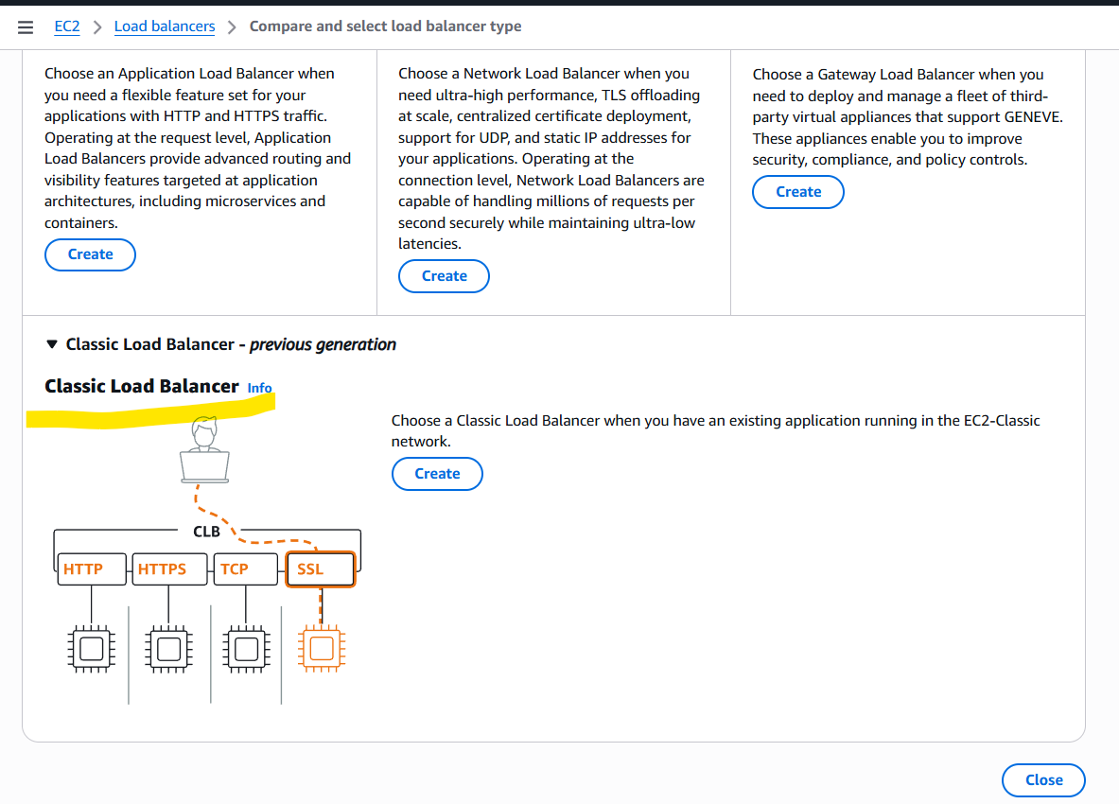

Load balancer name is created and scheme is updated to “Internet-facing”

Updated VPC and subnets attached to two different zones.

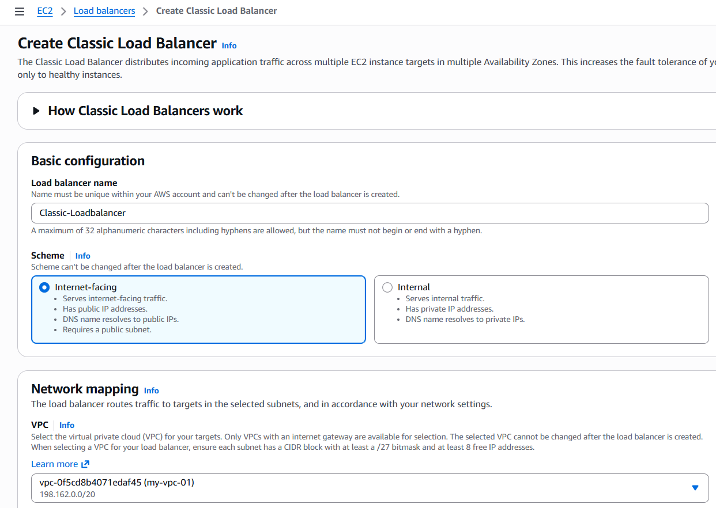

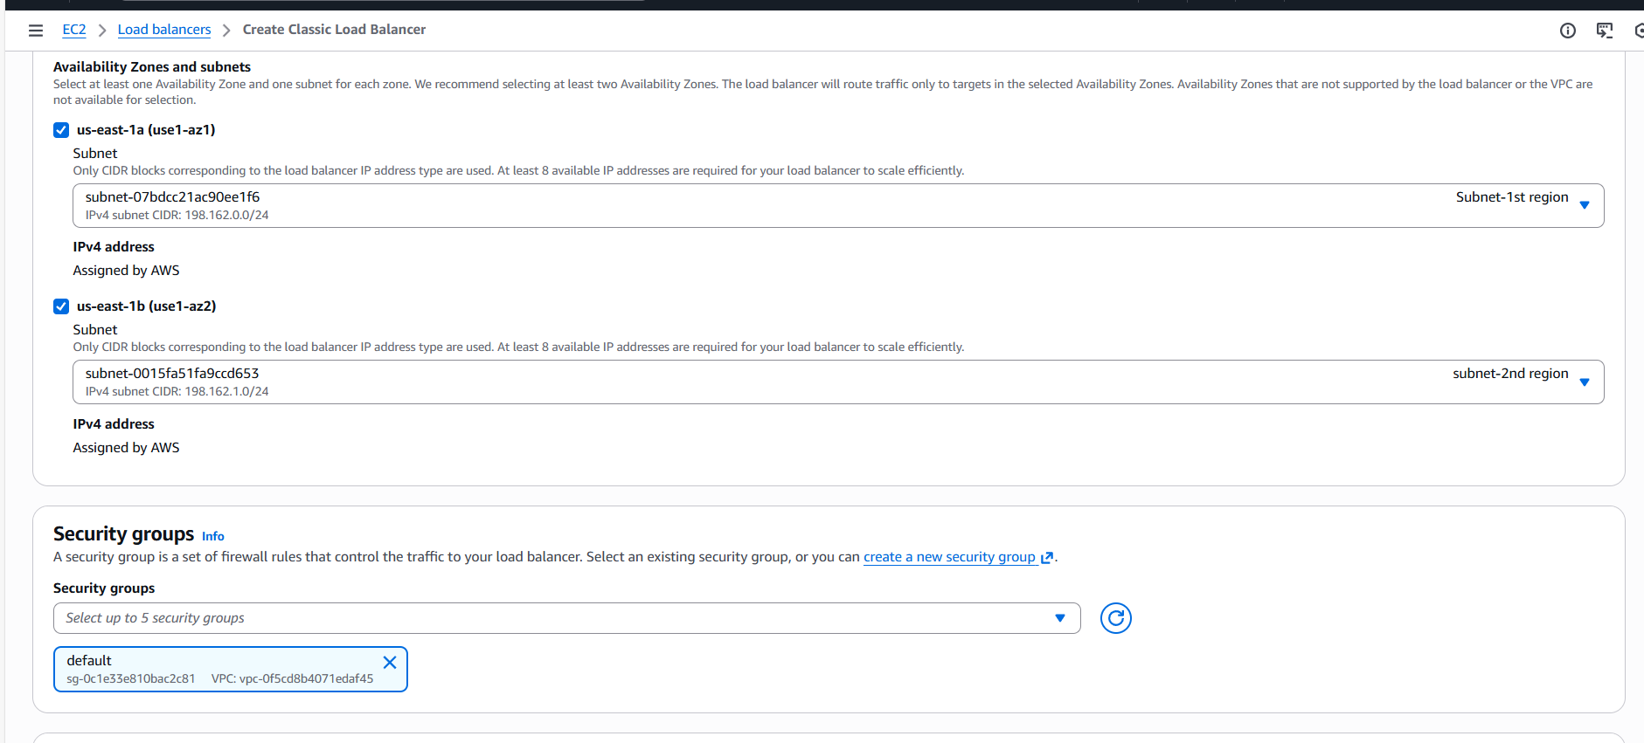Updated listeners according to the Apache package.

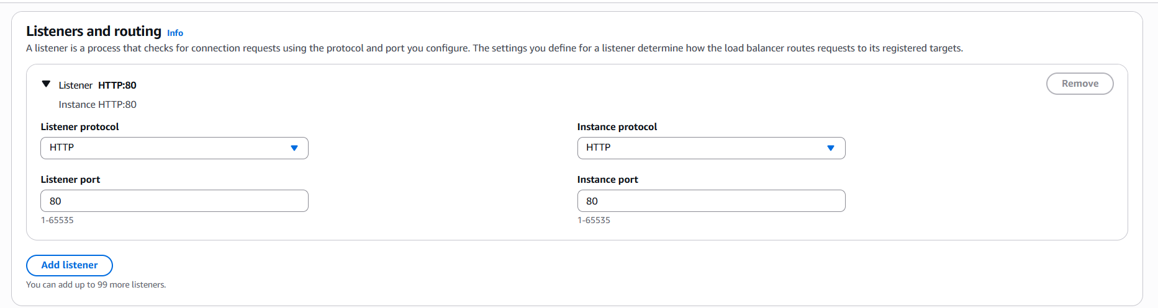

Selected the Health path as per the Apache package.

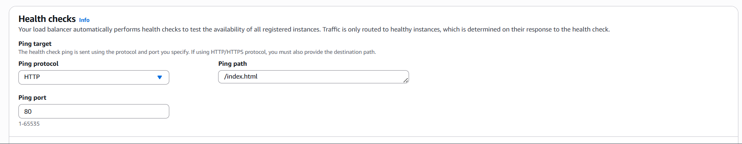

Attached 2 instances and we can see its running as expected. 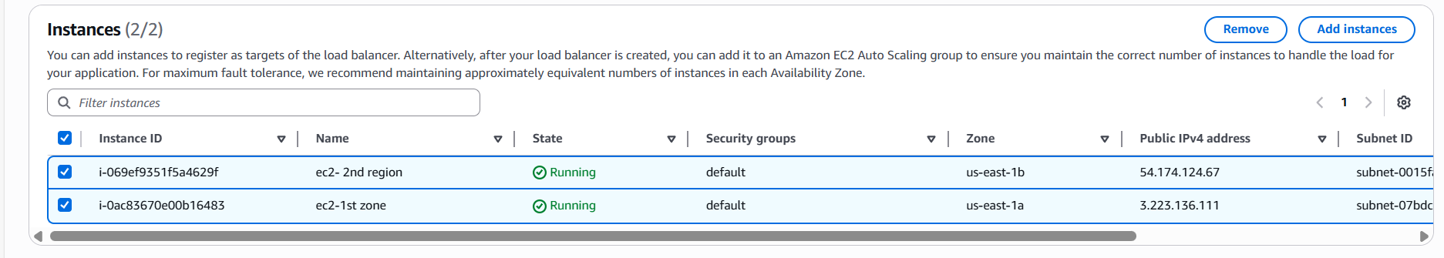

Select the Attributes timing and continue to the final step.

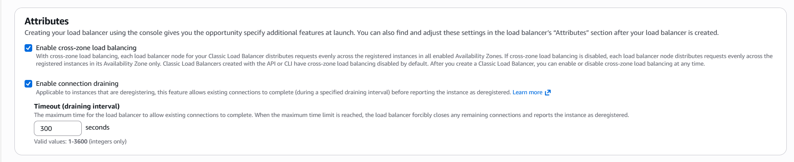

Review the summary and create Load balancer.

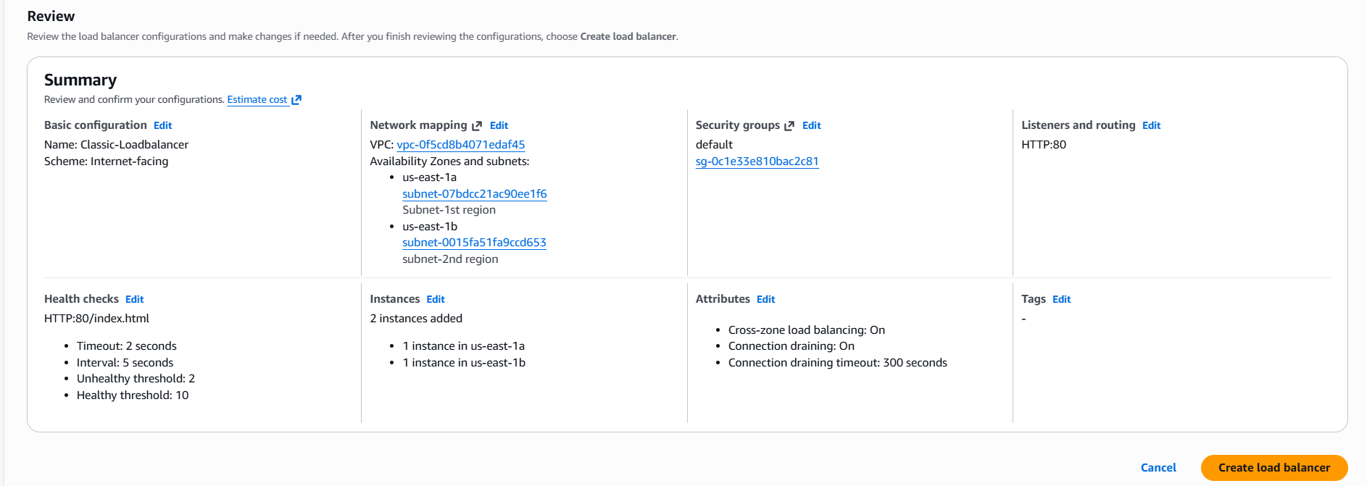

Classic Load balancer created successfully.

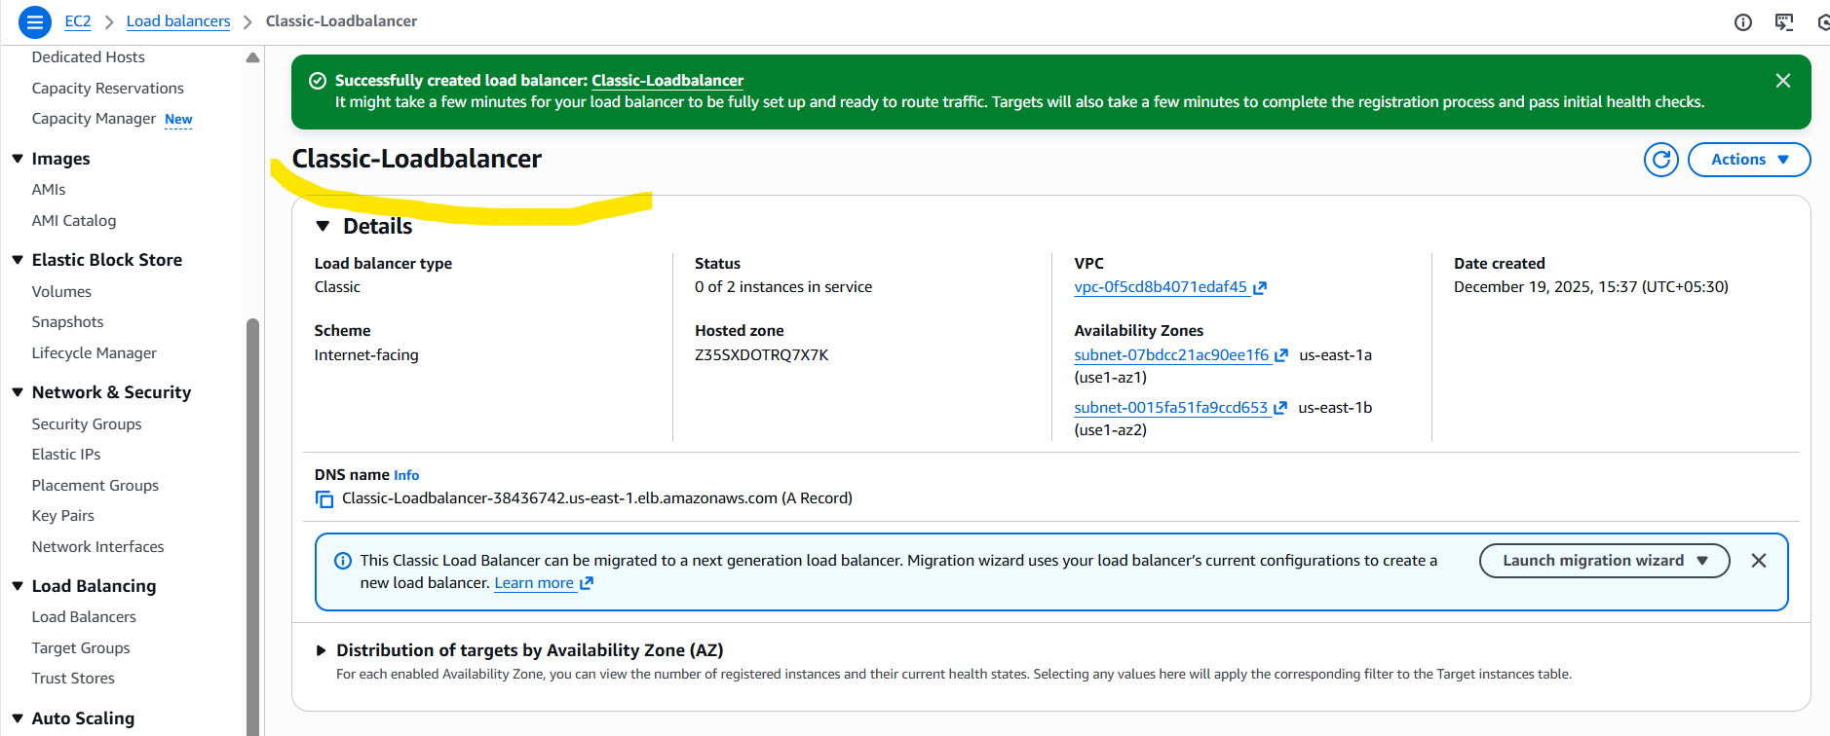

**2.Configure Network Load balancer:**

Earlier in the Classic Load balancer, we created a VPC, 2 ec2S, 2 subnets in 2 different regions.

So, we shall go ahead and create a network load balancer.

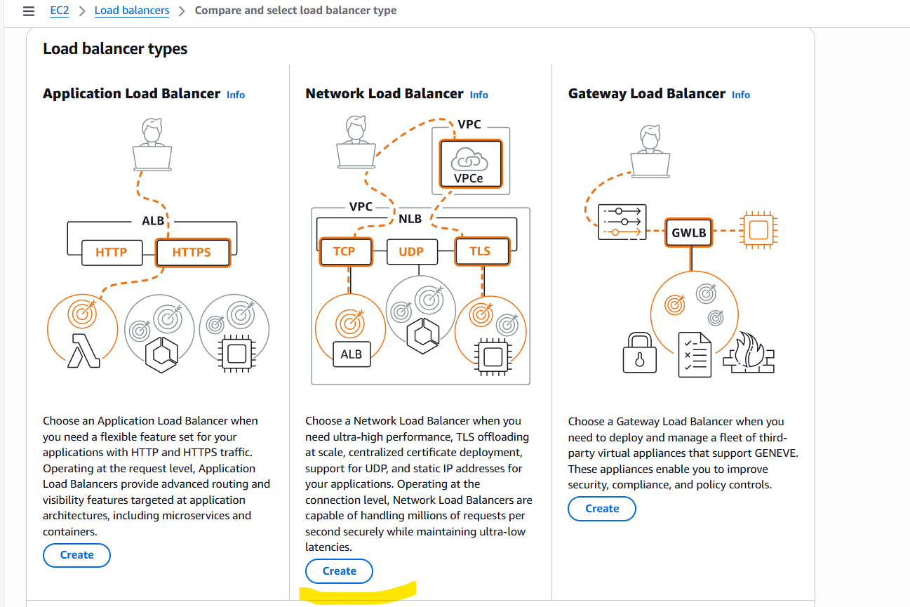

Provide a name to the Load balancer and scheme will be Internet facing.

IP address type will be IPV4.

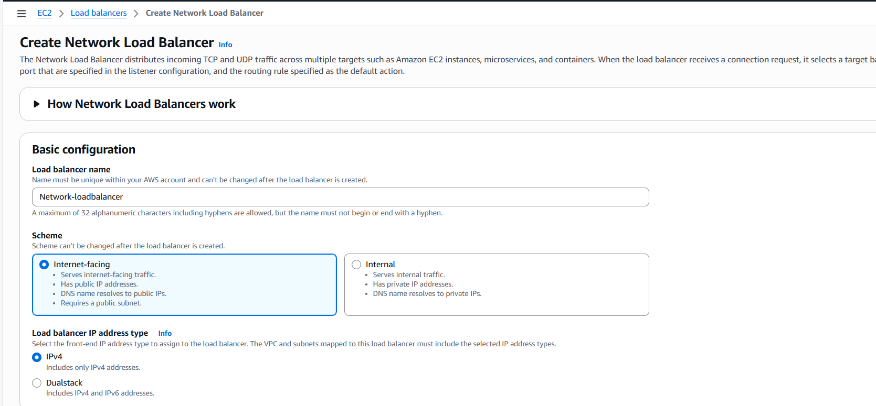

Attached VPC and 2 subnets from 2 availability zones.

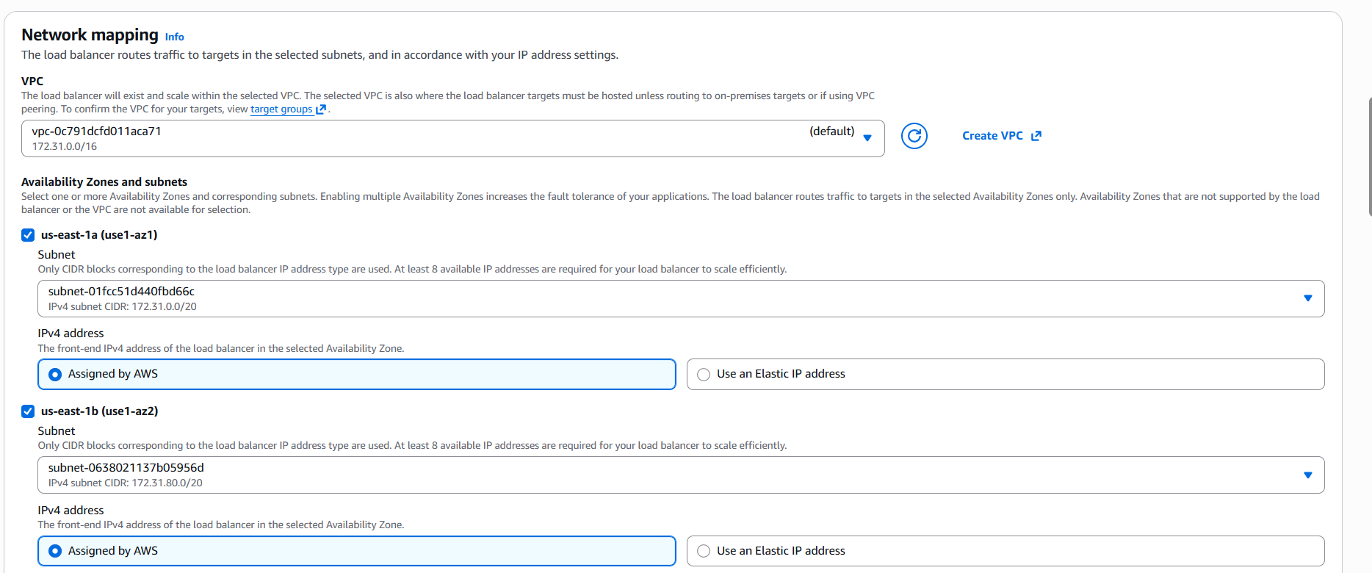

We need to provide listeners for the application to hear in the port. We provided TCP/80.

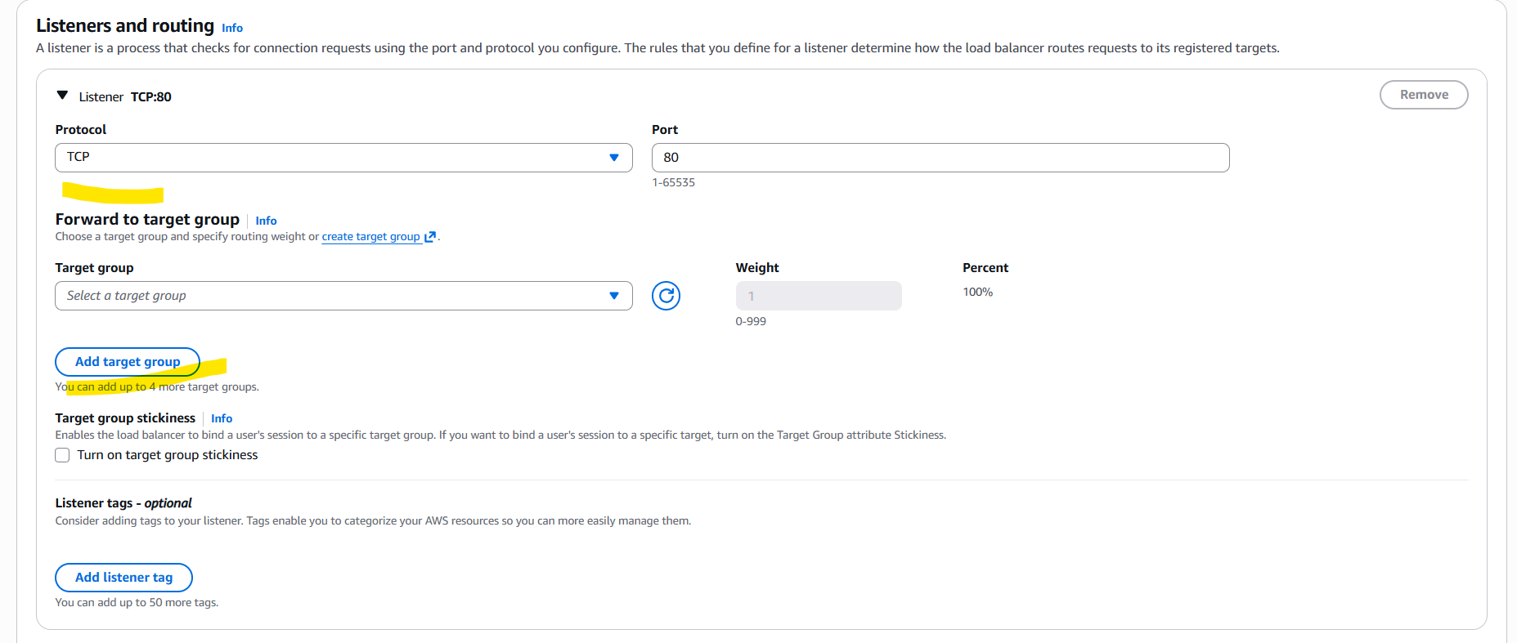

Now, we need to add Target groups to work closely with Load balancer and servers to verify Heath checks and re-routing to other instances as per traffic demand.

Provided name for the Target group and protocol selected as TCP/80.

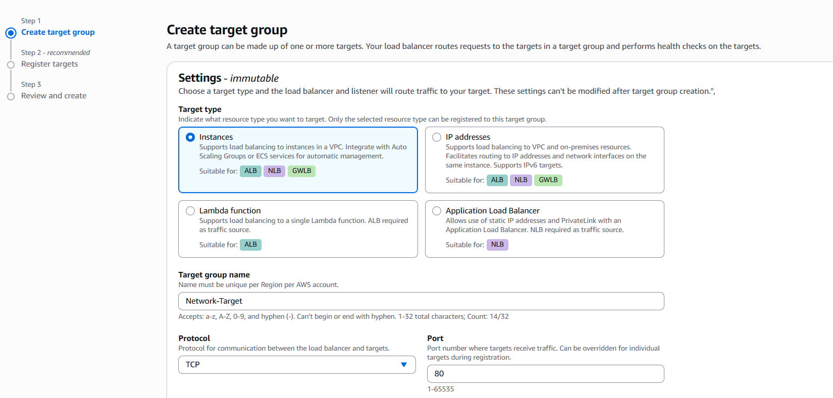

Attached VPC and Health checks path can be attached.

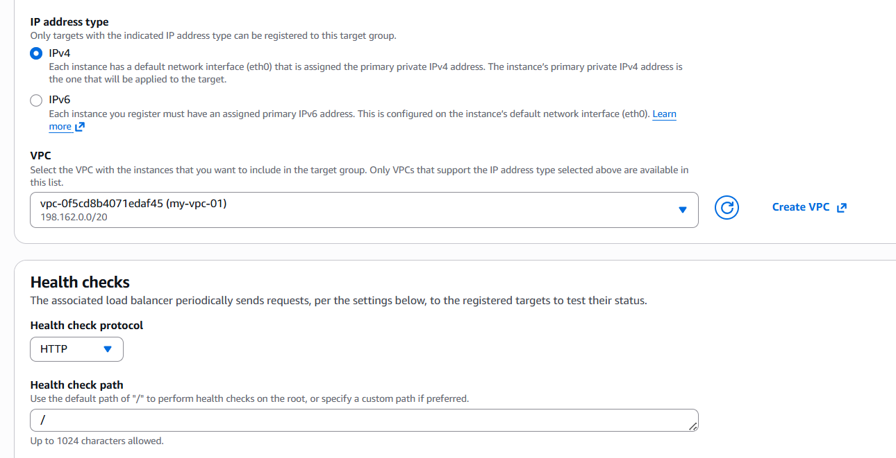

Health check port should work as per below configurations.

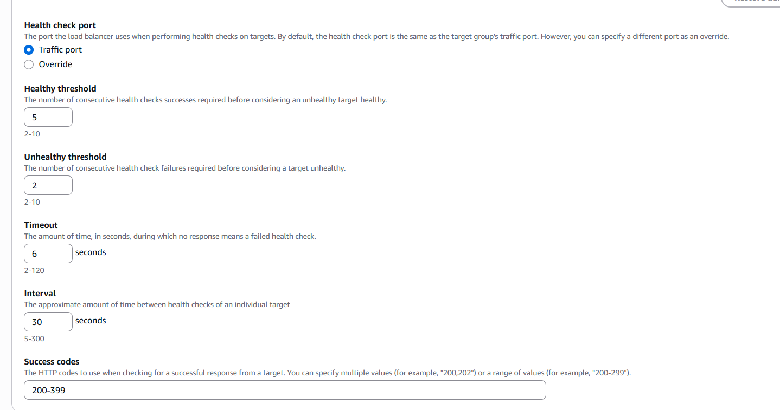

Selected the two instances running and marked as pending as well.

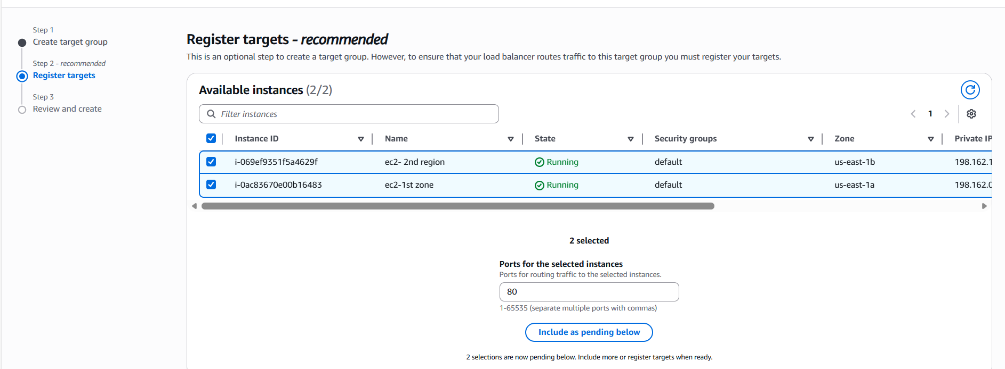

Target groups successfully created and lets go back to Load balancer and include the Target group.

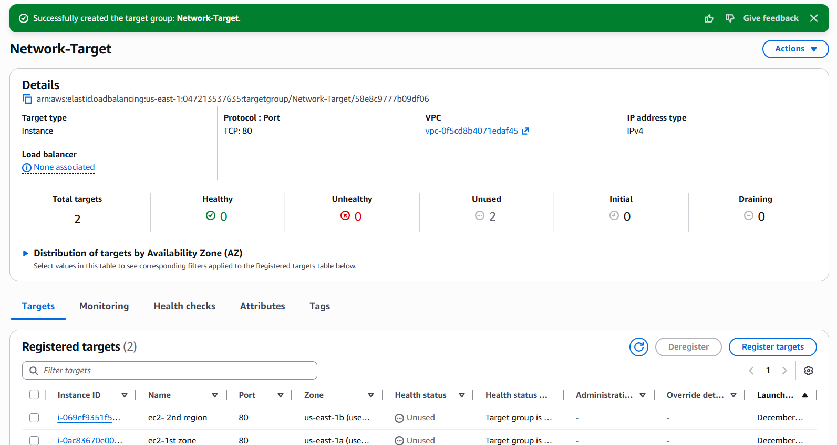

Now, back to Load balancer and updated the Target groups to identify the health checks and instances attached.

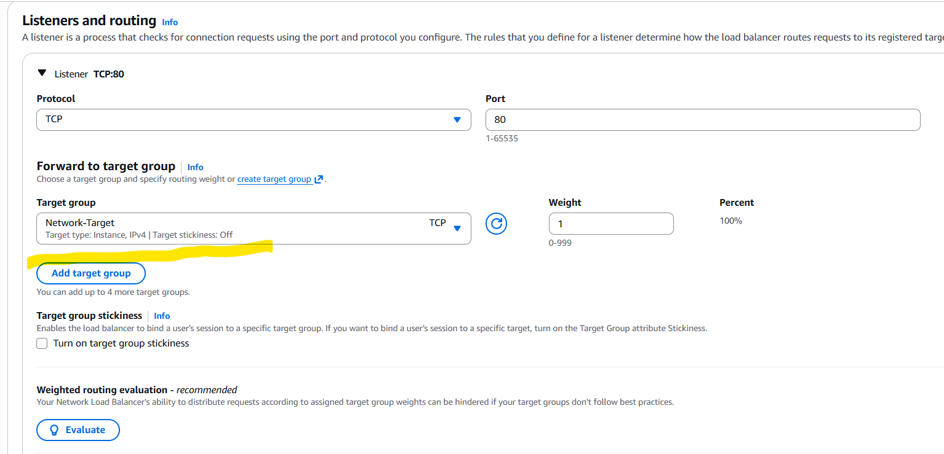

Network load balancer created successfully.

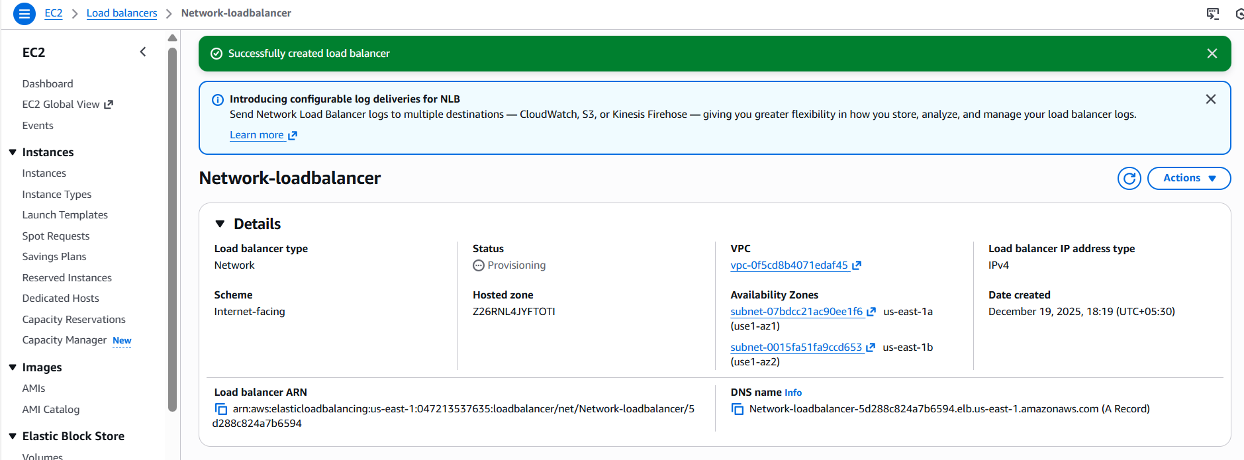

**3.Configure Application Load balancer:**

Earlier we have created NLB and CLB with application Apache installed, so we shall directly start with creating ALB.

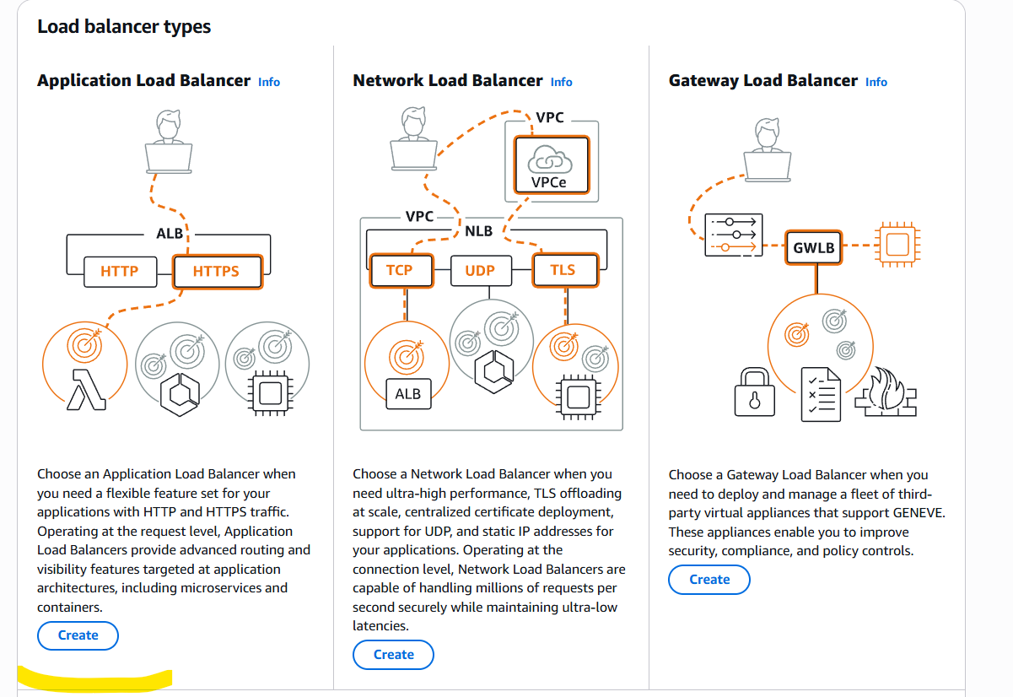

Created ALB name as Application-load balancer and Scheme as Internet-facing.

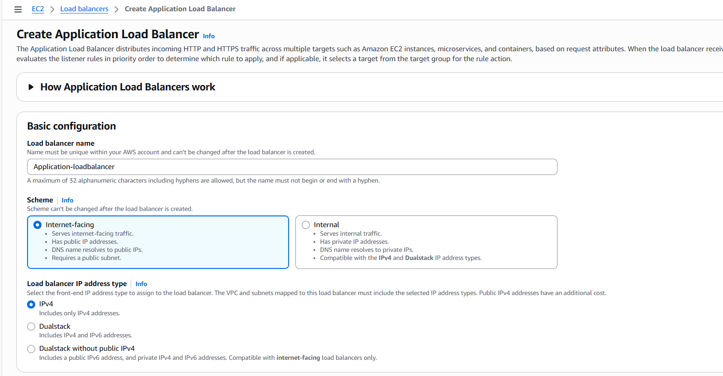

Listeners port number is 80 for my application Apache.

Now, its time to navigate to Target groups to attach in ALB.

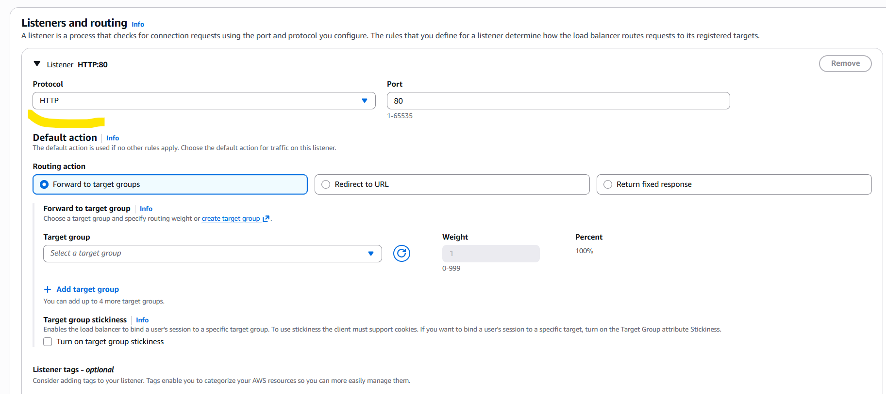

Navigated to Target groups and named Application-load balancers and scheme will be Internet-facing.

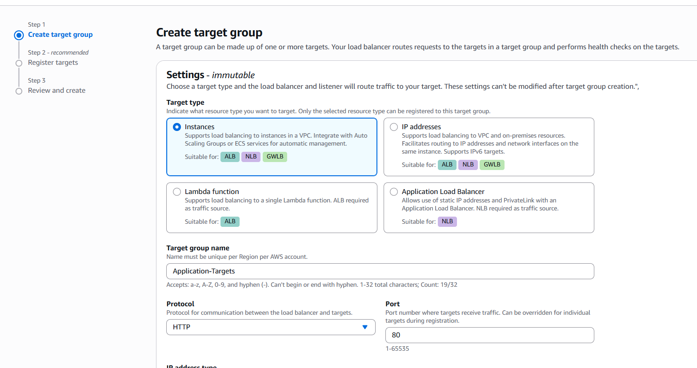

Protocol port is 80 for my application and VPC is attached to the TG.

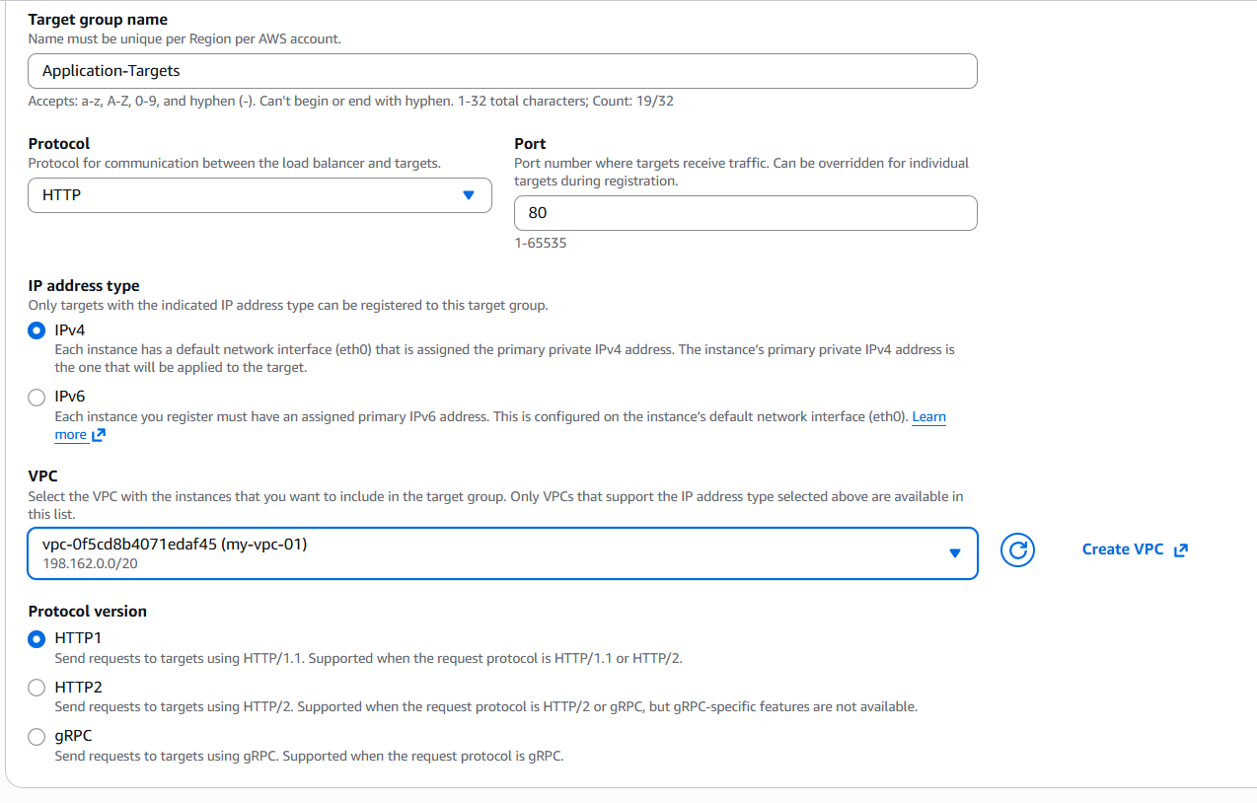Health Checks will be default.

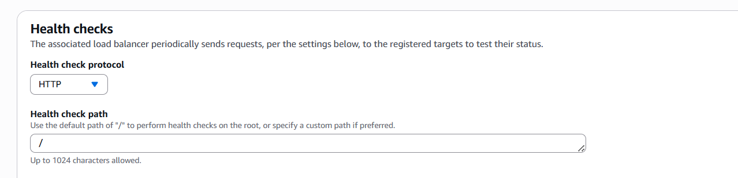

Instances has been selected and marked as review pending.

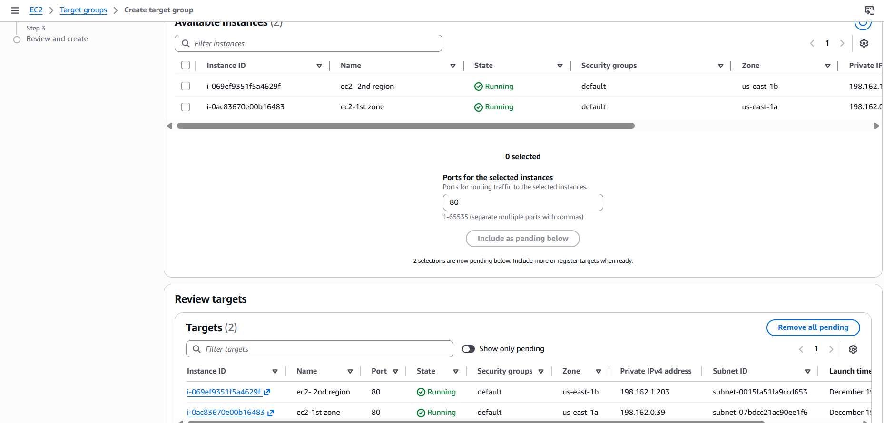

Target groups successfully created.

Now let’s attach the Target groups to Application load balancer.

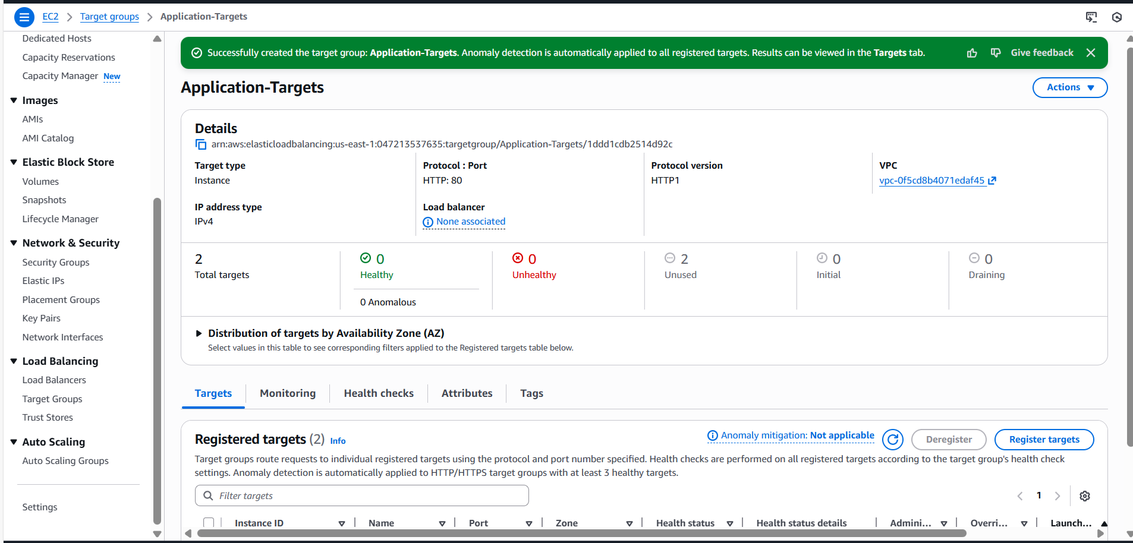

Attached the Target groups to my ALB.

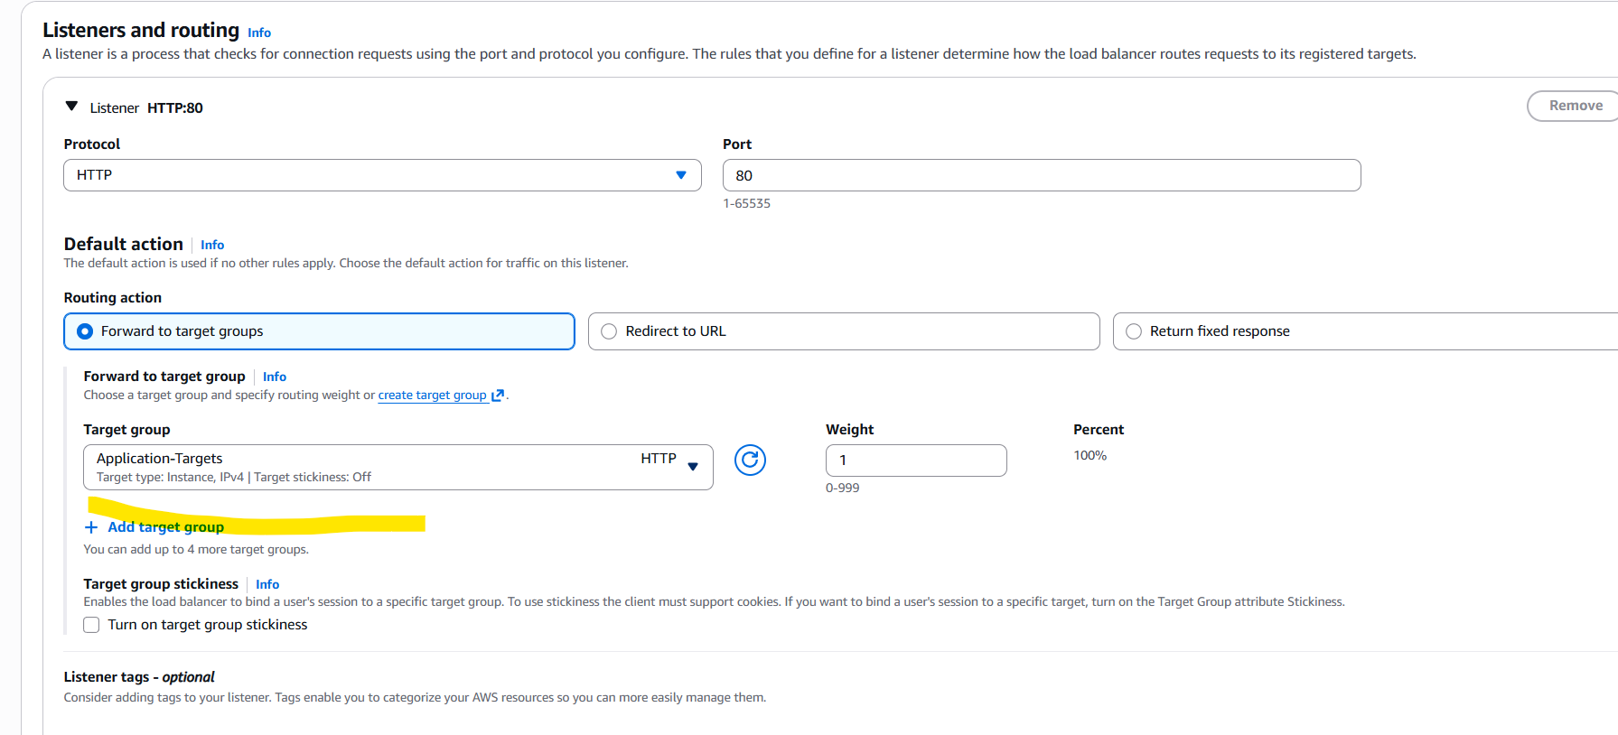

ALB is successfully created.

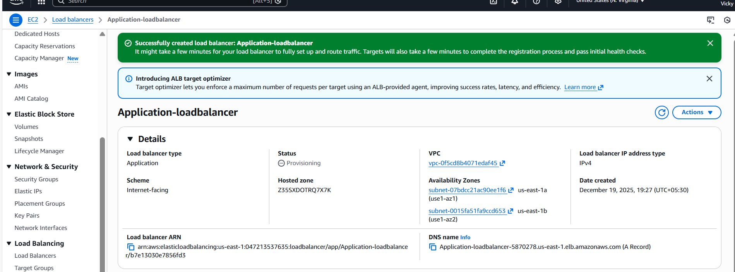

**4.Attach SSL for application load balancer:**

**5.Map Application load balancer to R53:**

We have Application Load balancer created and ready, so we shall navigate to GoDaddy and verify the DNS in active state.

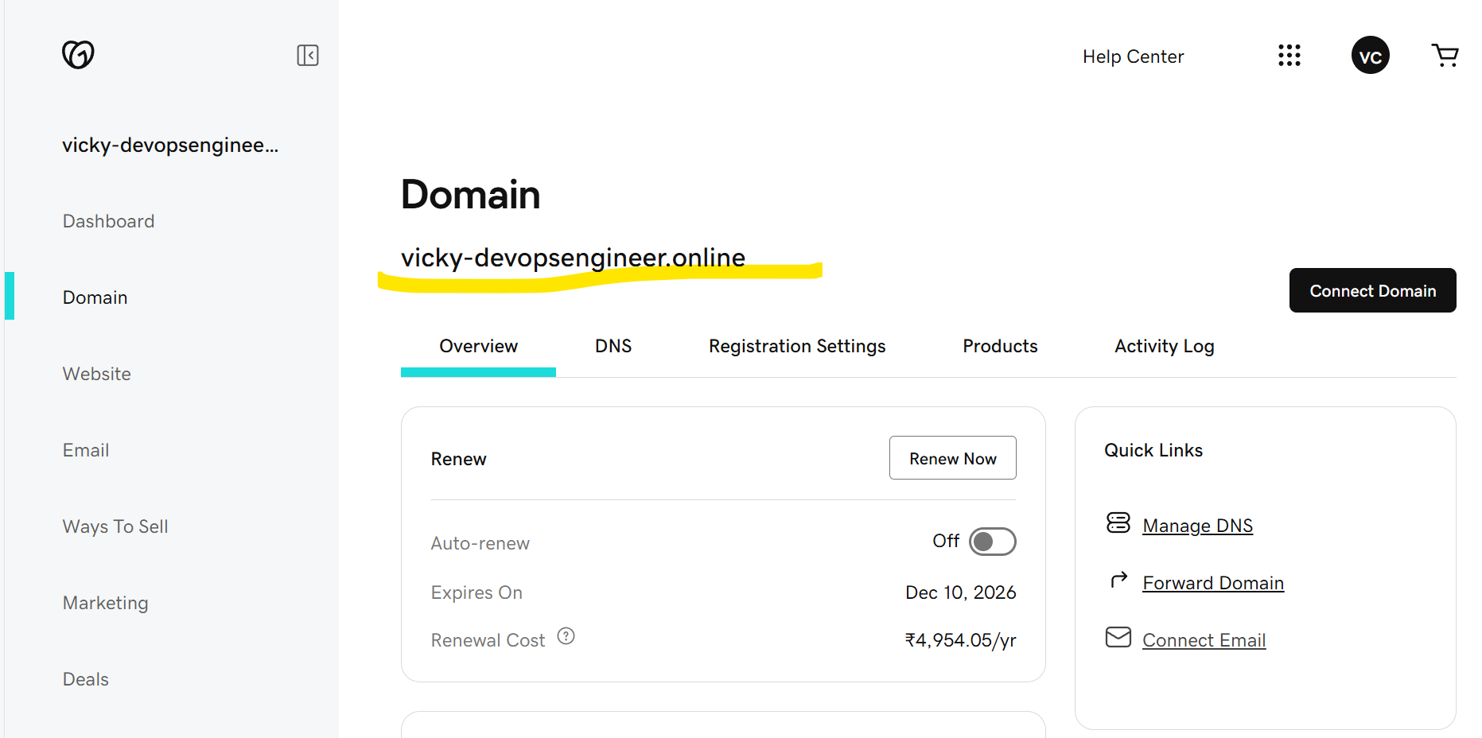

Navigate to Route53 and host the services.

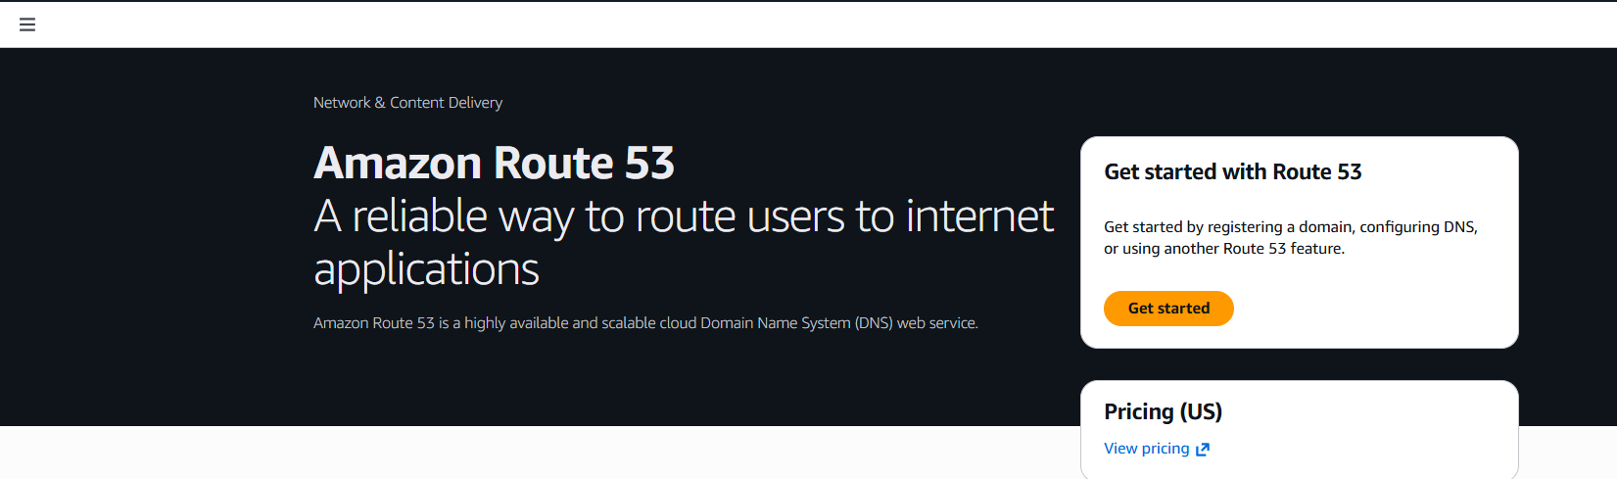Here, we are hosting our domain in R53, because we have created our Domain in GoDaddy.

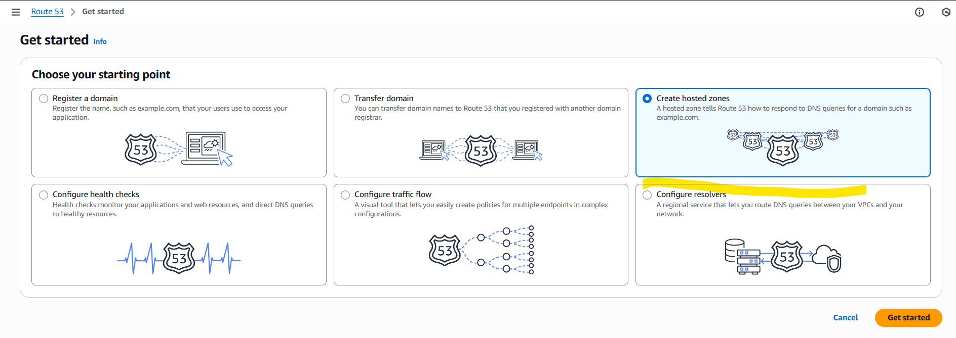Created hosted zones in R53 with Domain name same as GoDaddy.

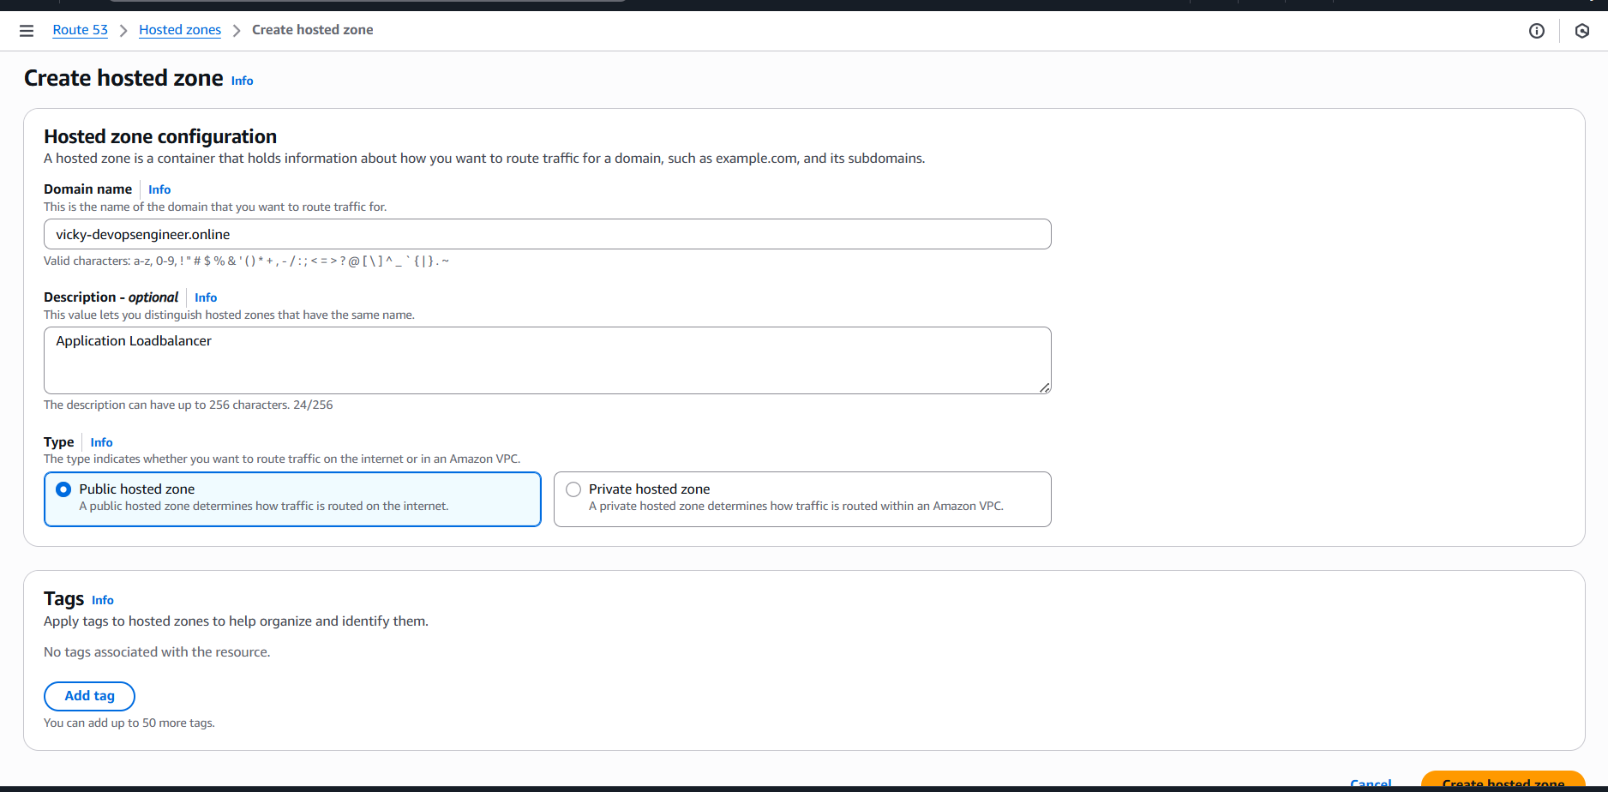

Our Domain has been hosted in R53, now, lets copy the Name servers and paste in GoDaddy NS.

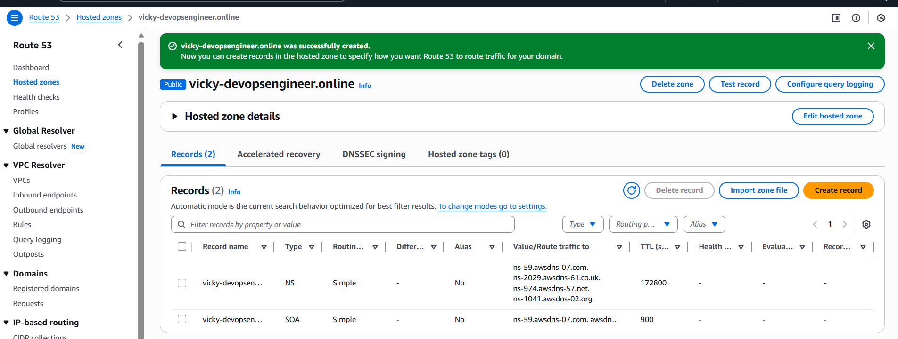Updated the Name severs in GoDaddy same as R53.

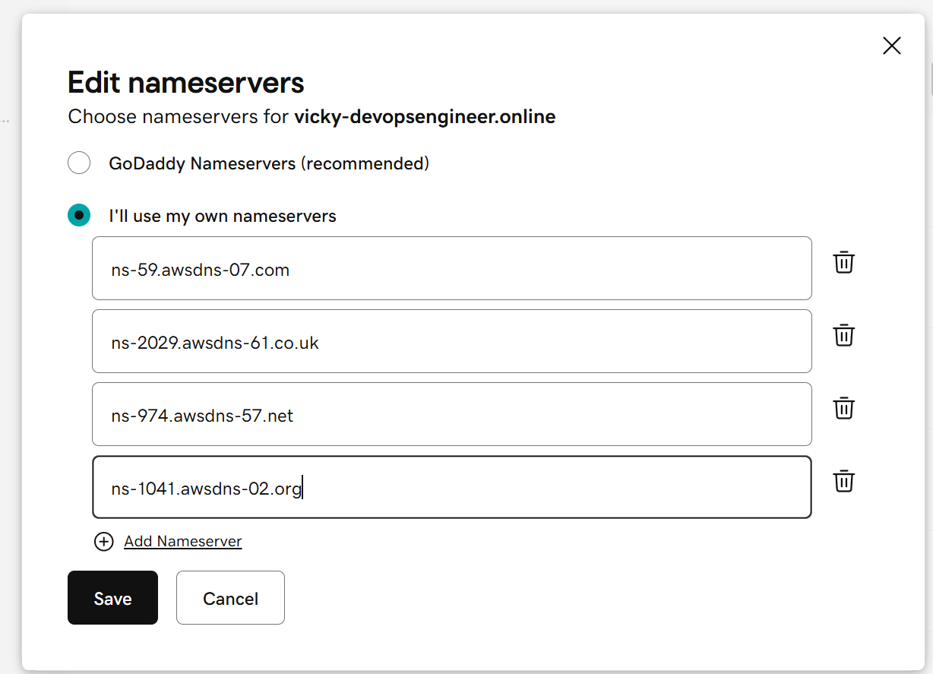

Navigate to ACM to obtain the SSL certificate.

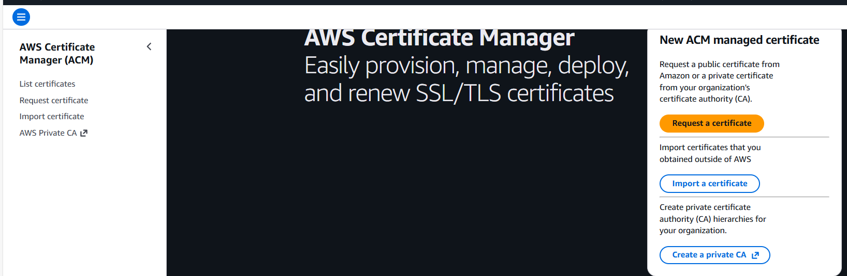

Updated our Domain name to match in ACM as well.

Enabled the export and Validation is required.

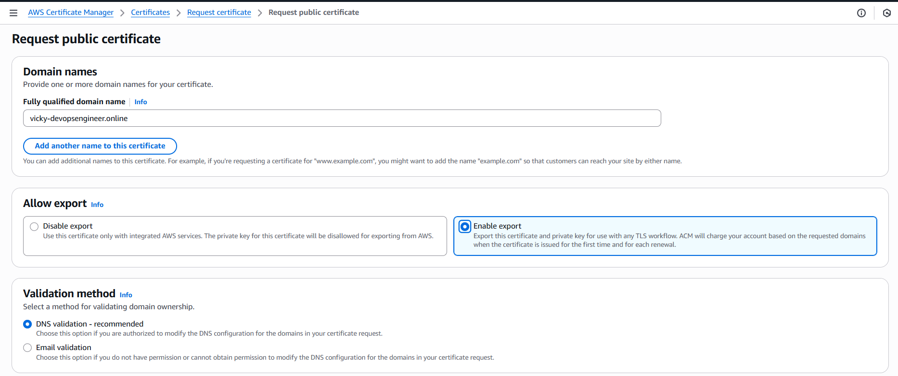

We have created the ACM certificate and waiting to receive from Amazon.

While we wait, there is one mandatory step to do, that’s we need to copy the CNAME code ands paste in R53, them Amazon verifies and provides SSL immediately.

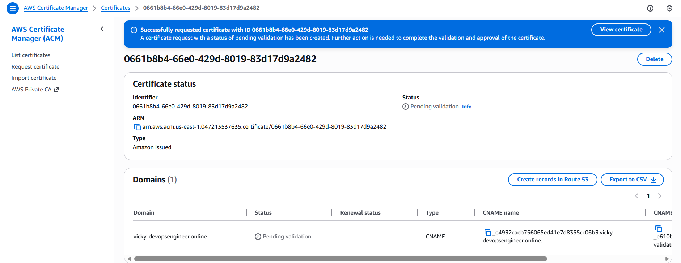

We have created a new record in R53 for CNAME, which Amazon provided for confirmation.

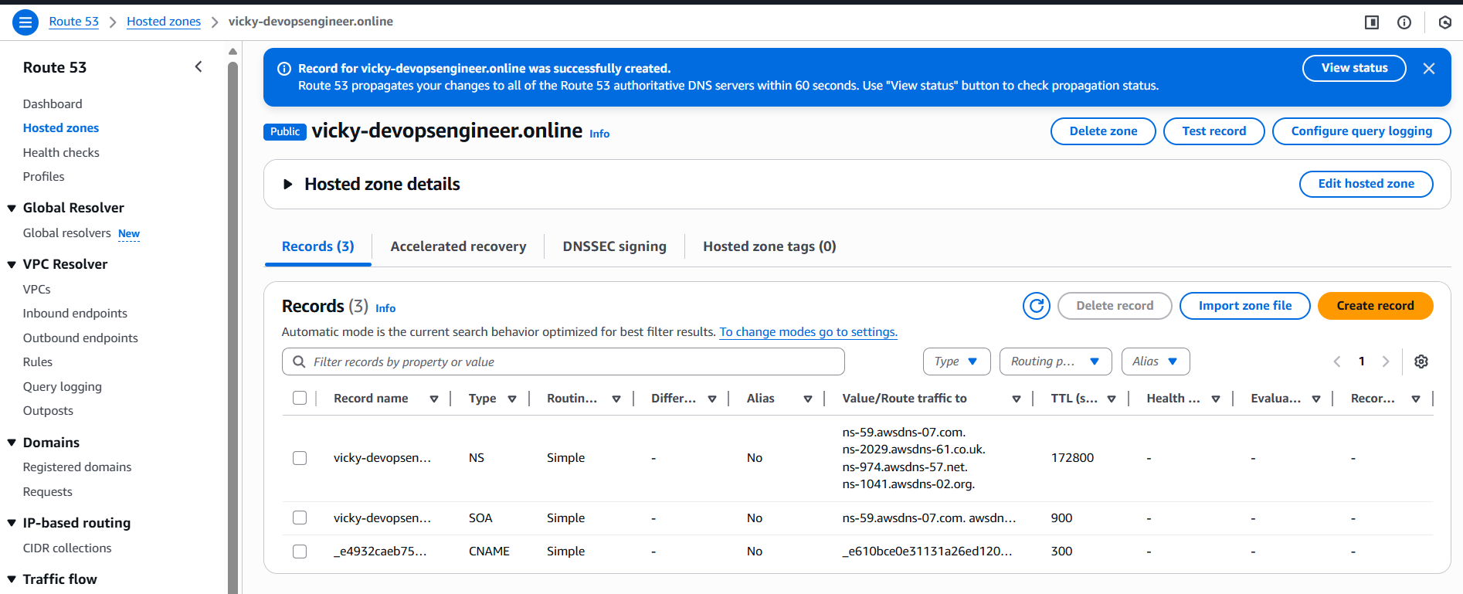

Amazon to provide the SSL certificate, it takes time, so we went ahead and created record A and enables Alias and select the load balancer.

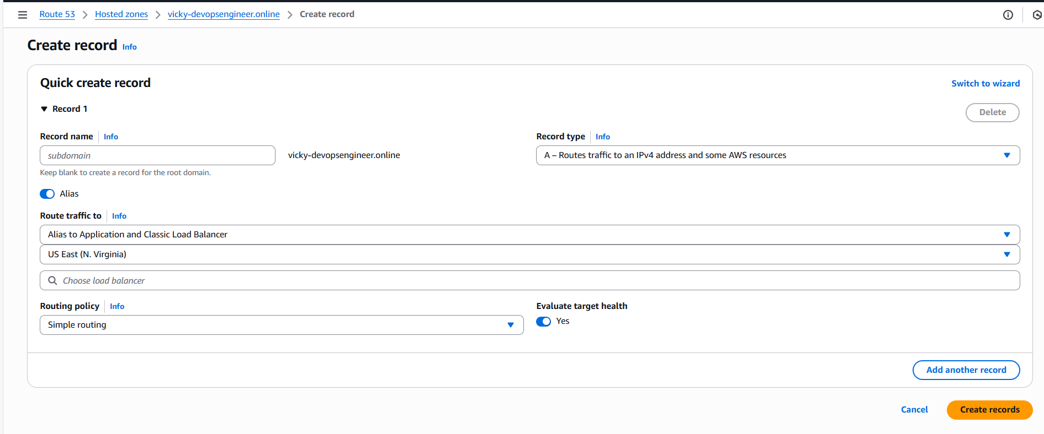

SSL certificate issued after such a long time.

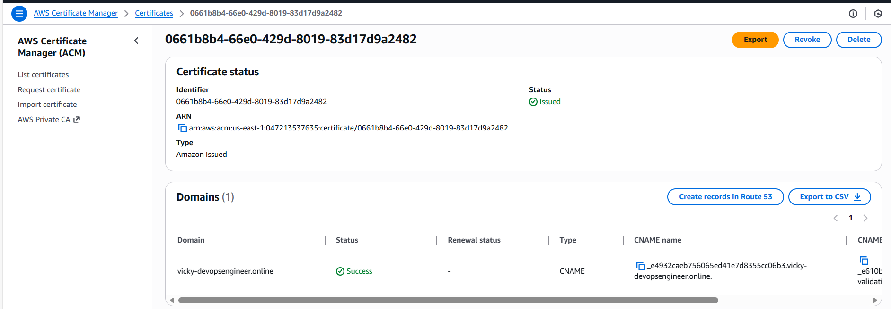

We shall navigate to ALB and add our HTTPS port 443.

Updated protocol to HTTPS/4443

Created new Target groups and provided port 443

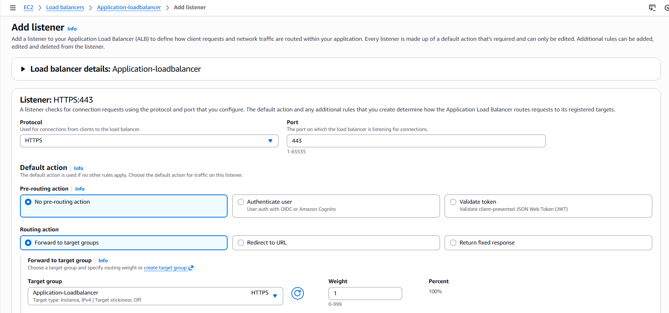

In the Secure Listener settings, we updated the ACM and attached SSL certificate.

Now, we will have our website secure and traffic will get distributed accordingly.

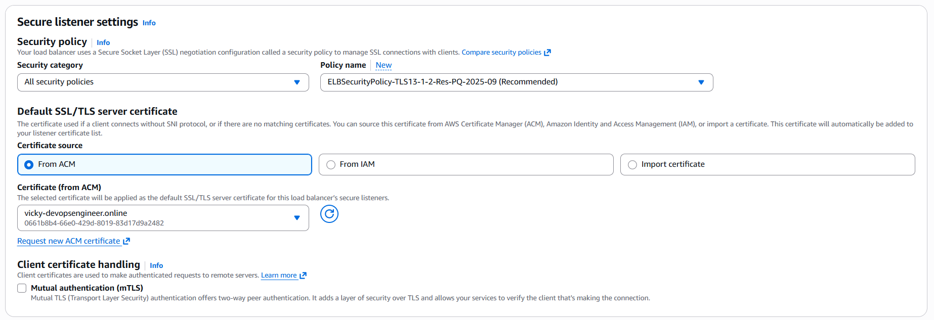

Successfully updated the ALB.

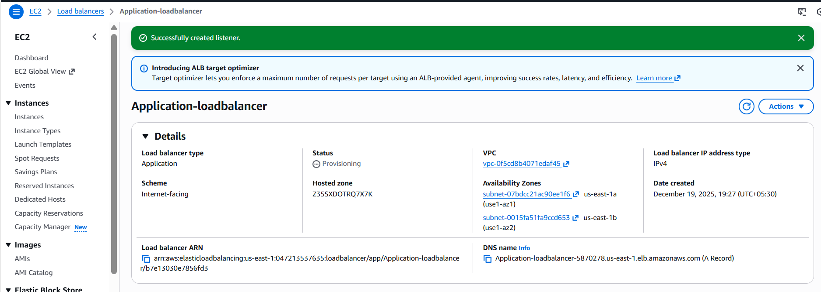

**Push the application load balancer logs to S3:**

Navigate to S3 and create a bucket.

Bucket created successfully.

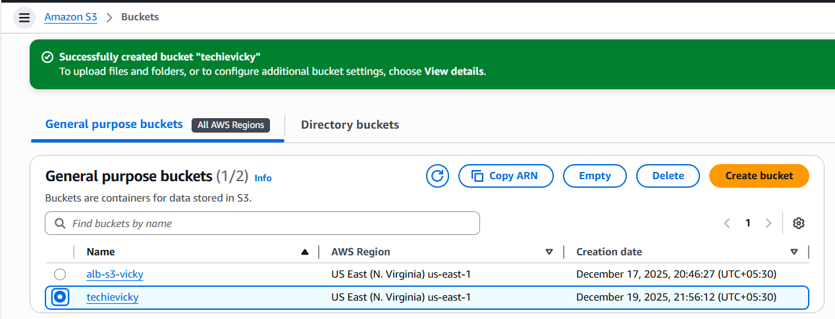

**Navigate to permissions tab in the created S3 bucket and update the below script to ensure the logs are automatically updated.**

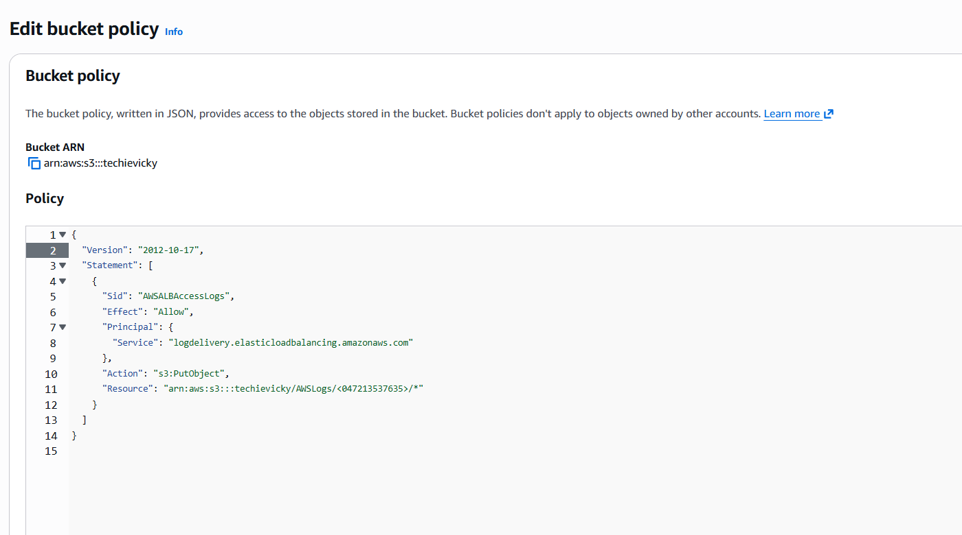

Navigate to Application load balancer and scroll to the tab- Attributes and scroll down to update the S3 logs.

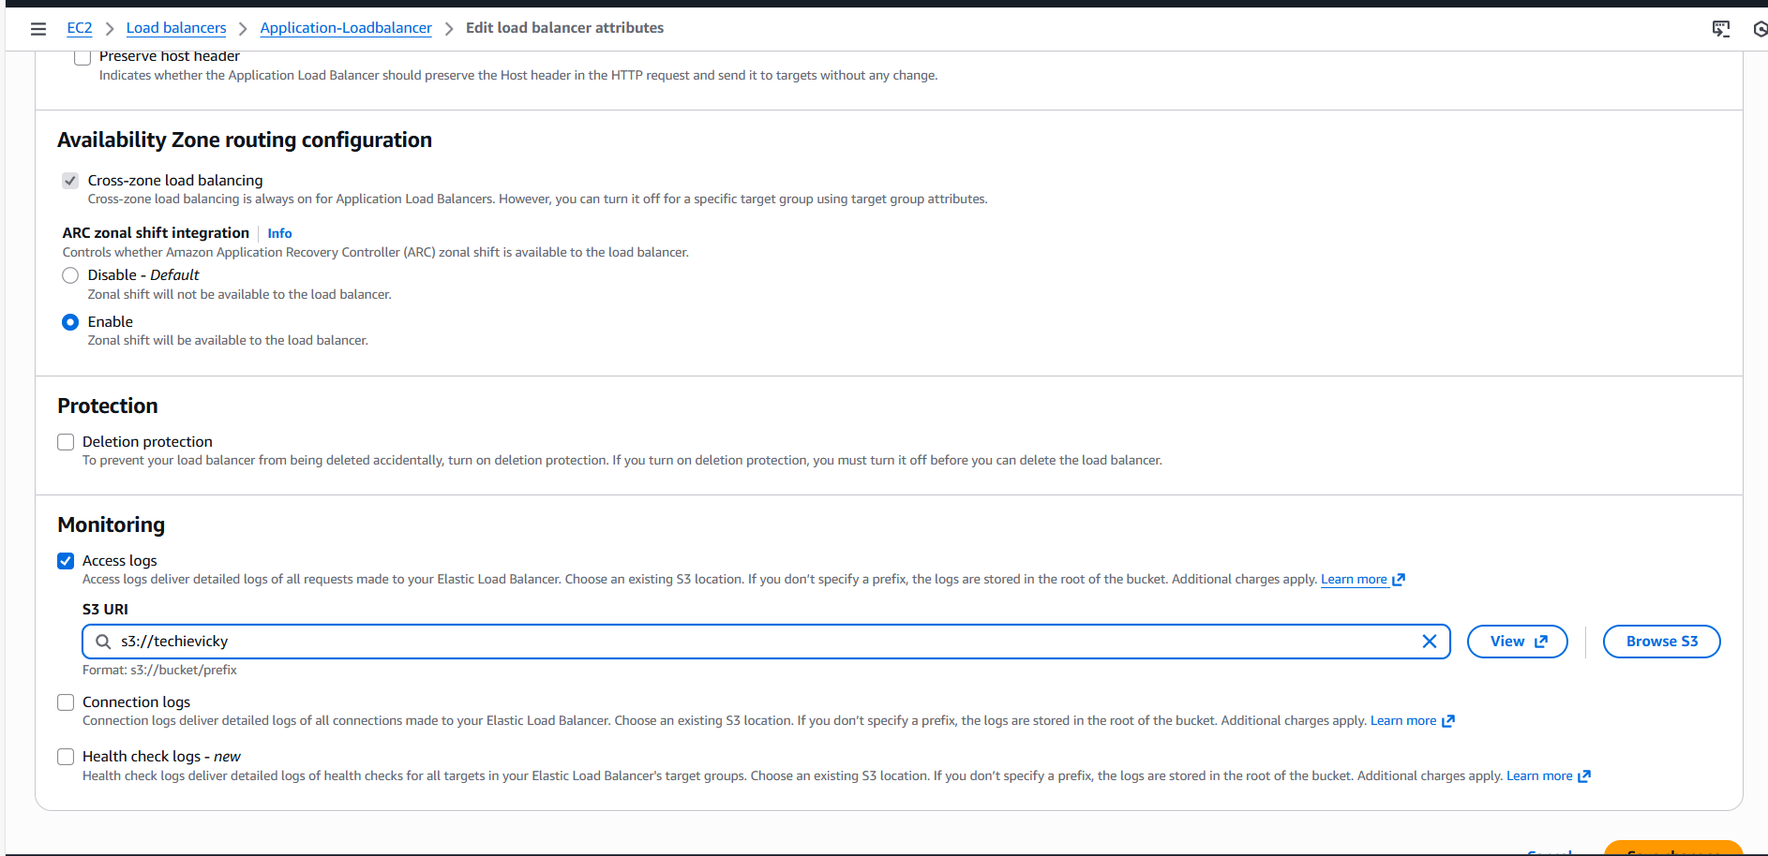

Finally, we were able to allow the policy to send the access logs to S3 automatically.

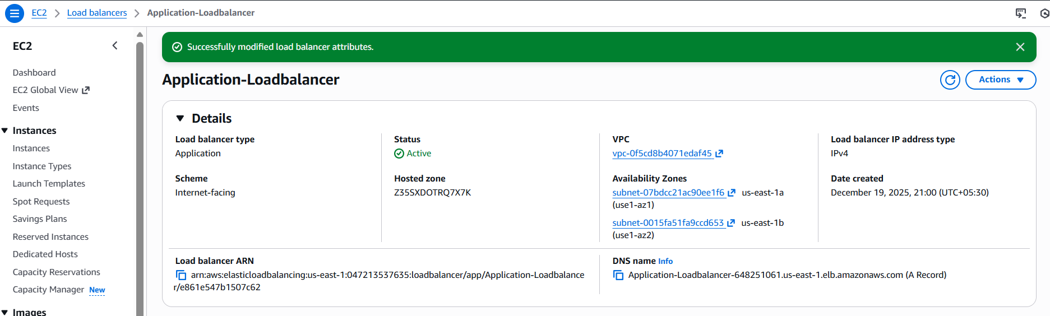

Success- We can see the access logs are sent to S3.

